**Software Analysis and Design (ADLC2)**

* **Use case Diagram**

**Description on the purpose of use case**

* **Analysis Model**

**Sequential Diagram**

**Class Diagrams**

* **Design Model**

**Statechart Diagram**

* **Data Model (Database Design)**

**Logical Data Model (ERD)**

**Data Dictionary**

**Use Case Diagram (Summary)**

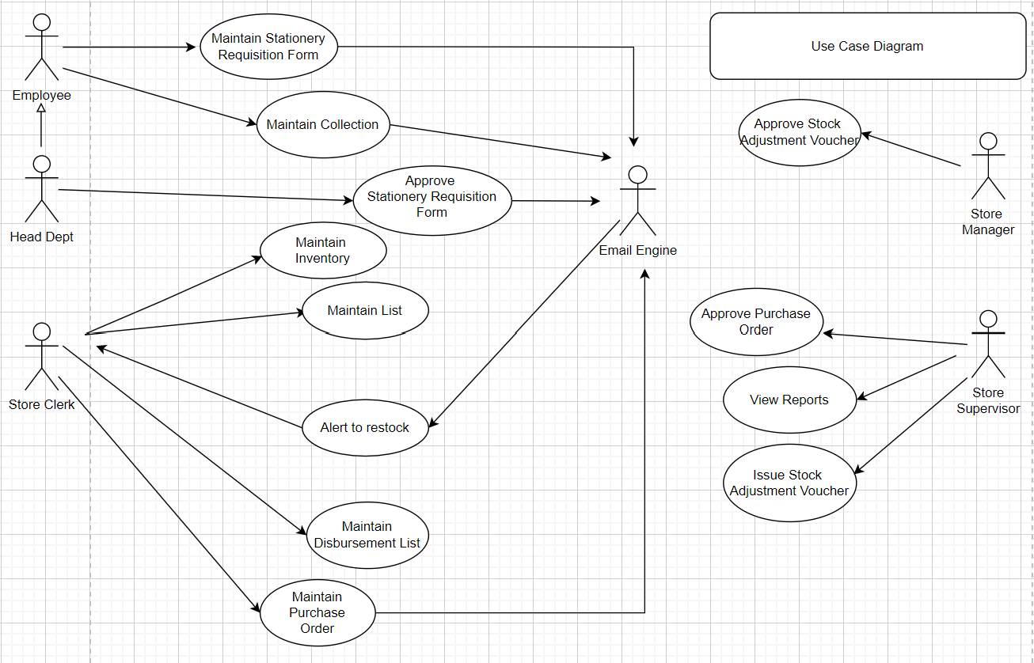

***Maintain Stationery Requisition Form:***

For employees in various departments to request for Stationery according to the stationery catalogue. Will be sent to the department head to approve first, after that sent to store clerk who will handle the request.

***Maintain Collection:***

Employees are allowed to choose the stationery collection point from six different locations. (Department still can change their preferred location point as well)

***Approve Stationery Requisition Form:***

Department Head to approve the stationary Requisition form.

***Maintain Inventory:***

Store clerk to record down the transactions from disbursement list, Delivery Order and Inventory Adjustment Voucher.

***Maintain List:***

(Includes Supplier, Department, Price)

Annually (or as needed), Store Clerk can go to the system to update the various list in the database.

***Alert to Restock:***

Alert Store Clerk when stocks inventory is low and restocking is required.

***Maintain Disbursement List:***

Actual quantity to be delivered (to the same Department) for each item will be noted in the disbursement list.

***Maintain Purchase Order:***

Store clerk will fill up the purchase order Form depending on the stock level of the items every two weeks.

***Approve Purchase Order:***

Alert the Store Supervisor to approve the pending Purchase Order.

***View Reports:***

Sales report including the amount of stationery ordered grouped by categories and stationery requisition trend of each department.

***Issue Stock Adjustment Voucher:***

The store supervisor will issue a stock adjustment voucher for anything under $250 per item adjustment.

***Approve Stock Adjustment Voucher:***

The store manager approves and issue the stock adjustment voucher that is above $250.

**Use Case: Maintain Stationery Requisition Form**

For employees in various departments to request for Stationery according to the stationery catalogue. Will be sent to the department head to approve first, after that sent to store clerk who will handle the request.

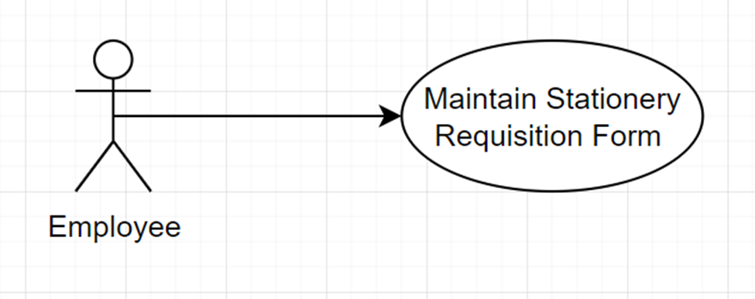

**Flow of Events:**

The use case begins when the Employee selects the “Maintain Stationery Requisition Form” option from the Main Menu.

***Basic flow – Create Requisition Form:***

*1.* *Employee enters the following details into the create screen of Stationery Requisition Form*

· *Dept code*

· *Employee number*

· *Item code*

· *Requested quantity*

*2.* *System validates format of data*

*3.* *System retrieves dept name, employee name, employee email address, item description, name of dept head*

*4.* *System displays dept name, employee name, employee email address, item description, name of dept head*

*5.* *System stores employee’s requisition form with a unique Requisition Form Num.*

*6.* *System sets the status of this requisition form as “Pending approve”*

*7.* *System displays successful message*

*8.* *System send email to employee who prompt requisition form to inform that the status of requisition form is “Pending approve”*

*9.* *System sends email to department head(according to which Dept code on requisition form), informing that there is a new request awaiting their approval*

***Alternate Flow:***

***1.1*** ***Update Requisition Form***

*1.* *Employee enter Requisition Form Num*

*2.* *System retrieve Requisition Form record*

*3.* *System displays Requisition Form details*

*4.* *Employee modifies Requisition Form fields*

*5.* *Employee submits the changes*

*6.* *System updates the Requisition Form record*

*7.* *System display successful message*

*8.* *System sends email to employee, informing updating is successful.*

***1.2*** ***Delete Requisition Form***

*1.* *Employee enter Requisition Form Num*

*2.* *System retrieve Requisition Form record*

*3.* *System displays Requisition Form details*

*4.* *Employee Confirms the delete operation*

*5.* *System delete the Requisition Form data*

*6.* *System display successful message*

*7.* *System send email to employee, informing delete is successful.*

***1.3*** ***Retrieve Requisition histories***

*1.* *Employee enters Employee Number*

*2.* *System validates Employee Number*

*3.* *System displays current and previous stationery requisitions with its disbursement status*

***1.4*** ***Requisition Form Exists***

*(Create Requisition Form flow) System finds an existing “Pending approve” Requisition Form with the same Employee Number and same Dept Code.*

*1.* *System displays an error message “You still have a requisition form awaiting for approve. Creation not allowed”*

*2.* *Employee can either click to send an urgent email to department head, or cancel the operation at which the use case terminates*

***1.5*** ***Requisition Form Not Exists***

*(Update or delete Requisition Form flow)System could not locate the Requisition Form or the status of this Requisition Form is not “Pending approve”(After head approved, status will be “approved”).*

*1.* *System display an error message, “Requisition Form not found”*

*2.* *Employee can either re-enter the Requisition Form Num, or cancel the operation at which the use case terminates*

***1.6*** ***Requisition histories Not Exist***

*(Retrieve Requisition Histories flow) System could not locate any current or previous requisition form.*

*1.* *System display an error message, “No requisition form”*

*2.* *Employee can either create a new requisition form or cancel the operation at which the use case terminates*

**Sequence Diagram:**

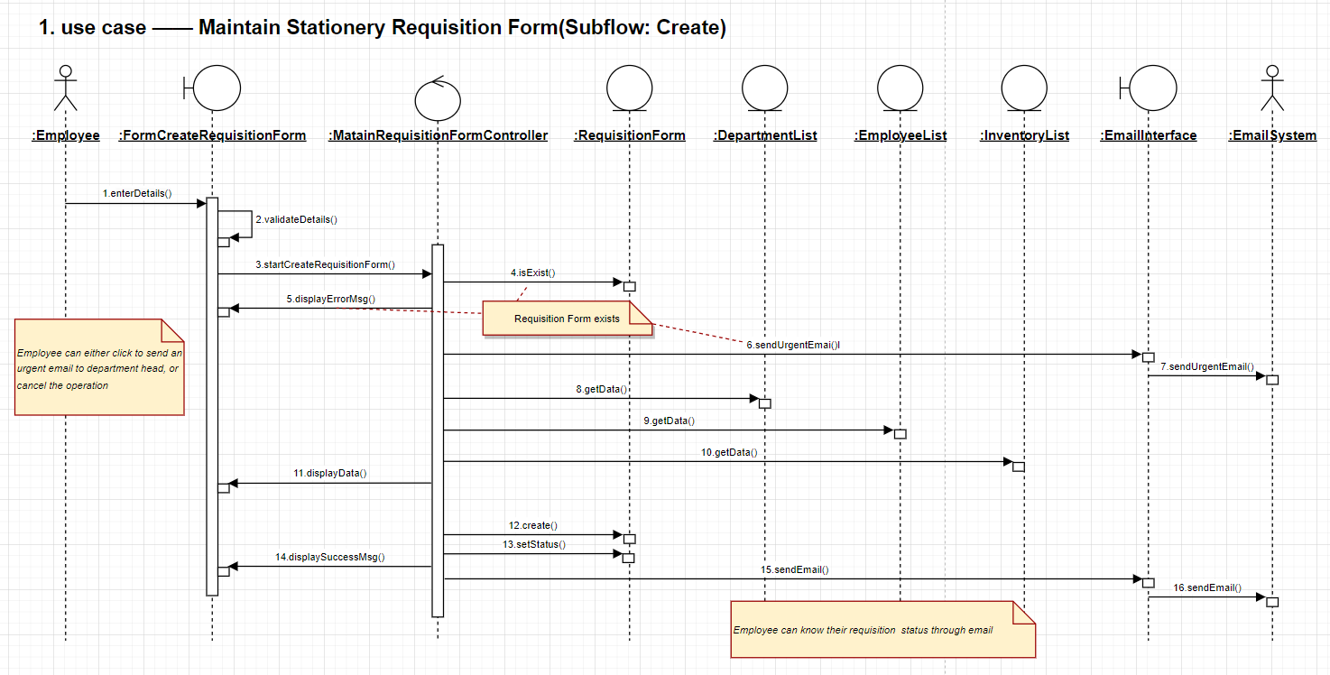

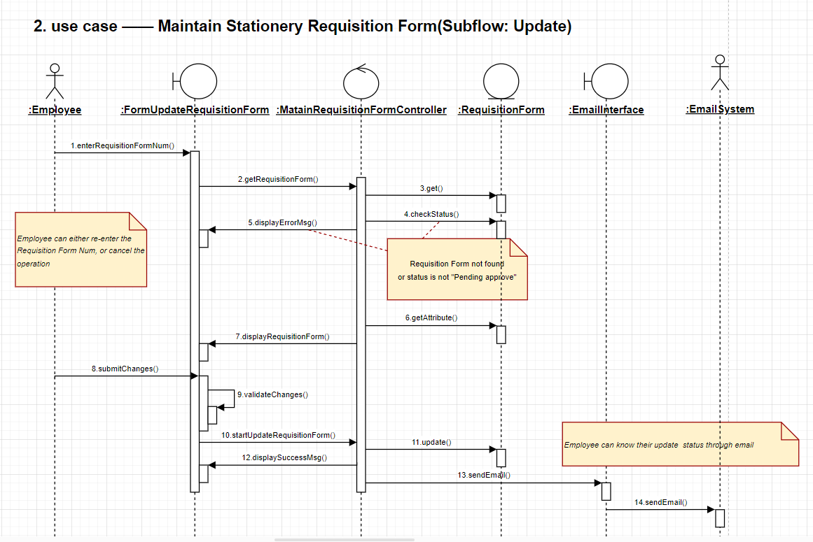

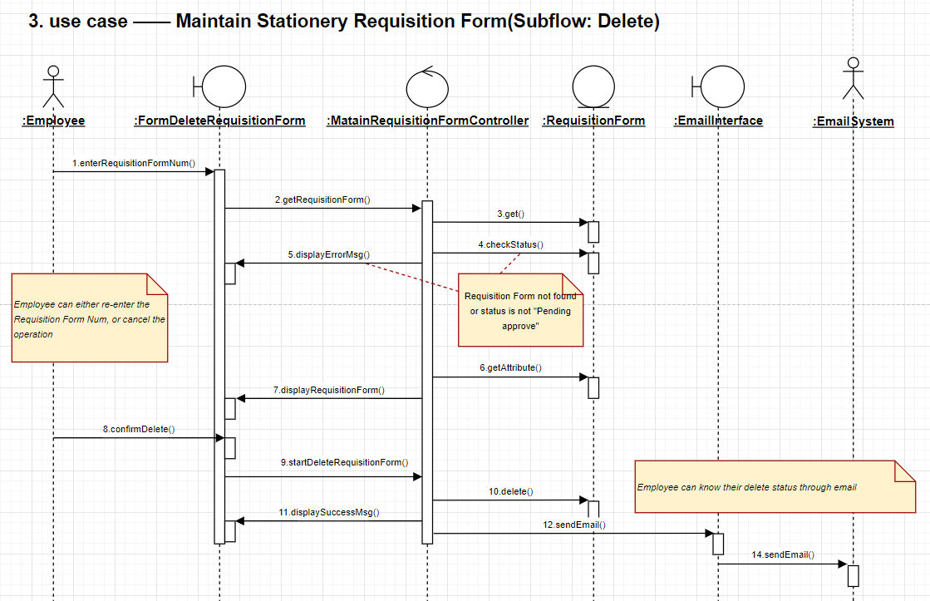

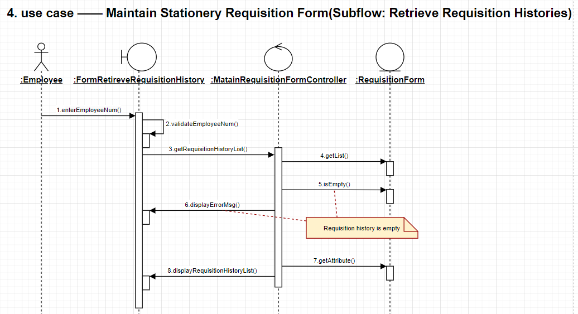

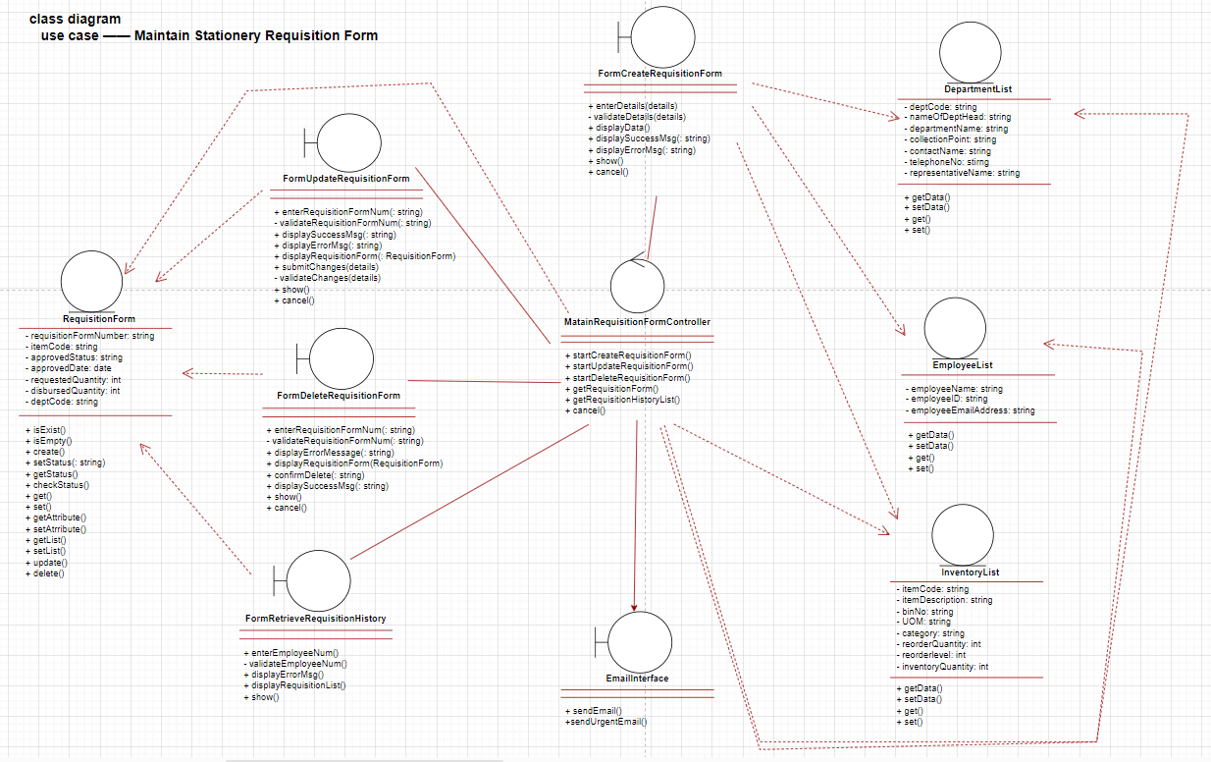

**Statechart diagram(Maintain Requisition Form):**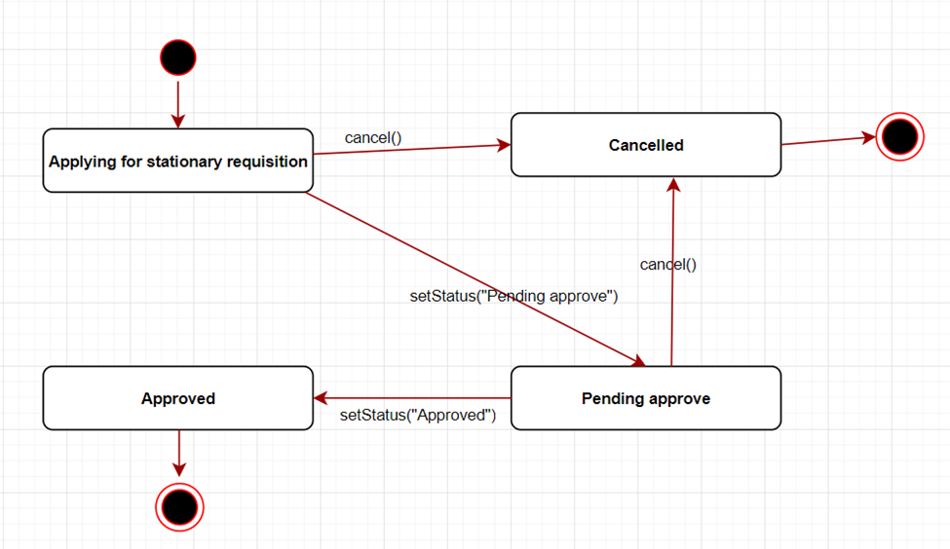

**Use Case: Maintain Collection**

Employees are allowed to choose the stationery collection point from six different locations. (Department still can change their preferred location point as well)

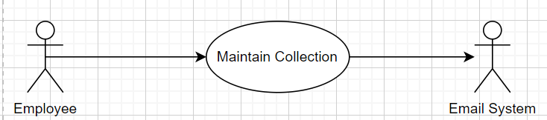

Sub Flow: Create

*Basic Flow:*

1. *Employee key in the following details to the Book Pick-Up Location Screen*

* *Requisition Number*
* *Pick-Up location*
* *Representatives Name*

1. *System validates format of data*
2. *System retrieves the Requisition Number*
3. *System stores the Representative Name*
4. *System create & stores the CollectionPoint*
5. *System send CollectionPoint record to Store Clerk via Email*
6. *System displays successful message*

*Alternate Flow:*

*Requisition Number Not Found*

*At Step 3 of Basic Flow*

*System Display a Message that Requisition Number is Not Found*

**Employee can only Book/Update Pick-Up Location Screen if:

1. Once the Store Clerk has processed the order and ready to dispatch:
   1. A ‘null’ location will be created, when employee comes and book, they will be updating the system
2. Store clerk has already processed the order and ready to dispatch
   1. Error Message of Requisition Number Not Found if Employee tries to Book a Pick-Up location
3. Can only update 24 hours before the stipulated Dispatch time
   1. Error Message of Unable to Update Pick Up Location

After Submitting the Stationery Requisition Form, Employee will have to select the pick up location

There will be a set of 6 places where the employee can choose from with the stipulated time

Also nomination of the POC to collect the stationery needs to be included.

Upon submission, if the employee likes to amend the Pick-Up location prior to the 2 hours before delivery, he can go online and update.

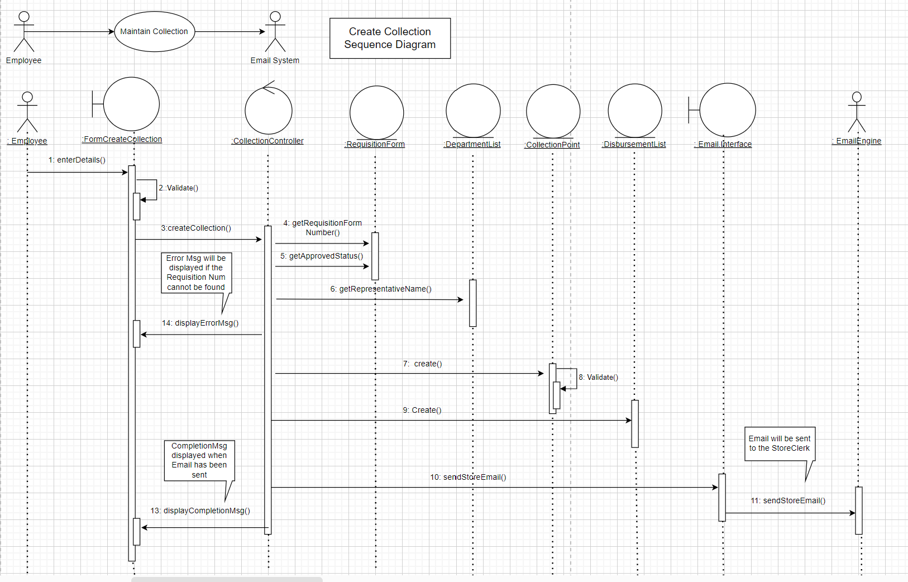

SubFlow: Update

*Basic Flow:*

1. *Employee key in the following details to the Book Pick-Up Location Screen*

* *Requisition Number*
* *Pick-Up location*
* *Representatives Name*

1. *System validates format of data*
2. *System retrieves the Requisition Number*
3. *System stores the Representative Name*
4. *System update & stores the CollectionPoint*
5. *System send CollectionPoint record to Store Clerk via Email*
6. *System displays successful message*

*Alternate Flow:*

*Requisition Number Not Found*

*At Step 3 of Basic Flow*

*System Display a Message that Requisition Number is Not Found*

**Employee can only Book/Update Pick-Up Location Screen if:

1. Once the Store Clerk has processed the order and ready to dispatch:
   1. A ‘null’ location will be created, when employee comes and book, they will be updating the system
2. Store clerk has already processed the order and ready to dispatch
   1. Error Message of Requisition Number Not Found if Employee tries to Book a Pick-Up location
3. Can only update 24 hours before the stipulated Dispatch time
   1. Error Message of Unable to Update Pick Up Location

After Submitting the Stationery Requisition Form, Employee will have to select the pick up location

There will be a set of 6 places where the employee can choose from with the stipulated time

Also nomination of the POC to collect the stationery needs to be included.

Upon submission, if the employee like to amend the Pick-Up location prior to the 2 hours before delivery, he can go online and update

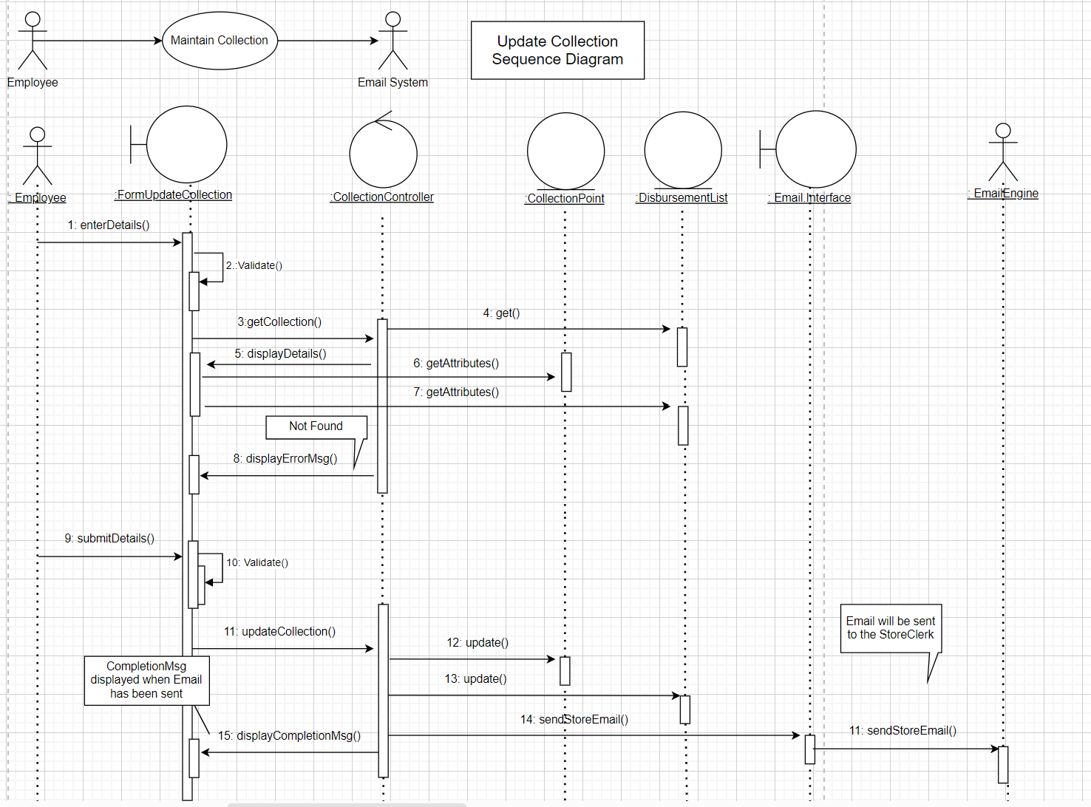

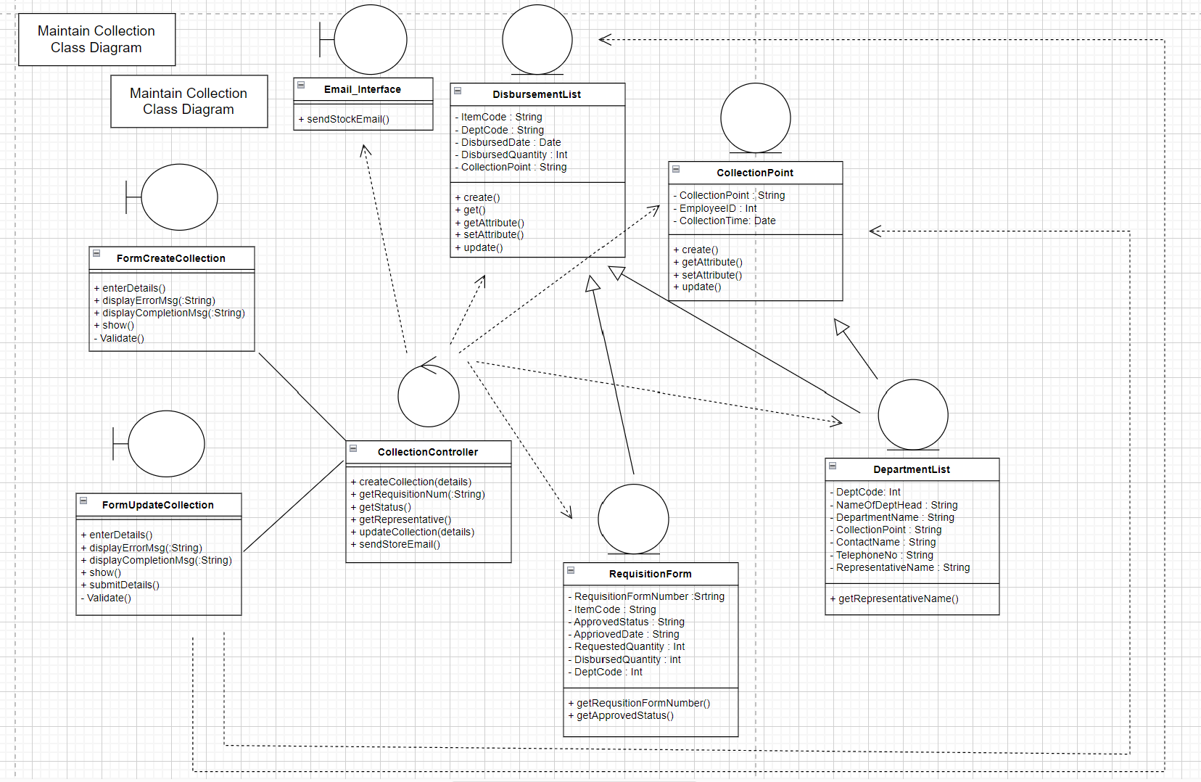

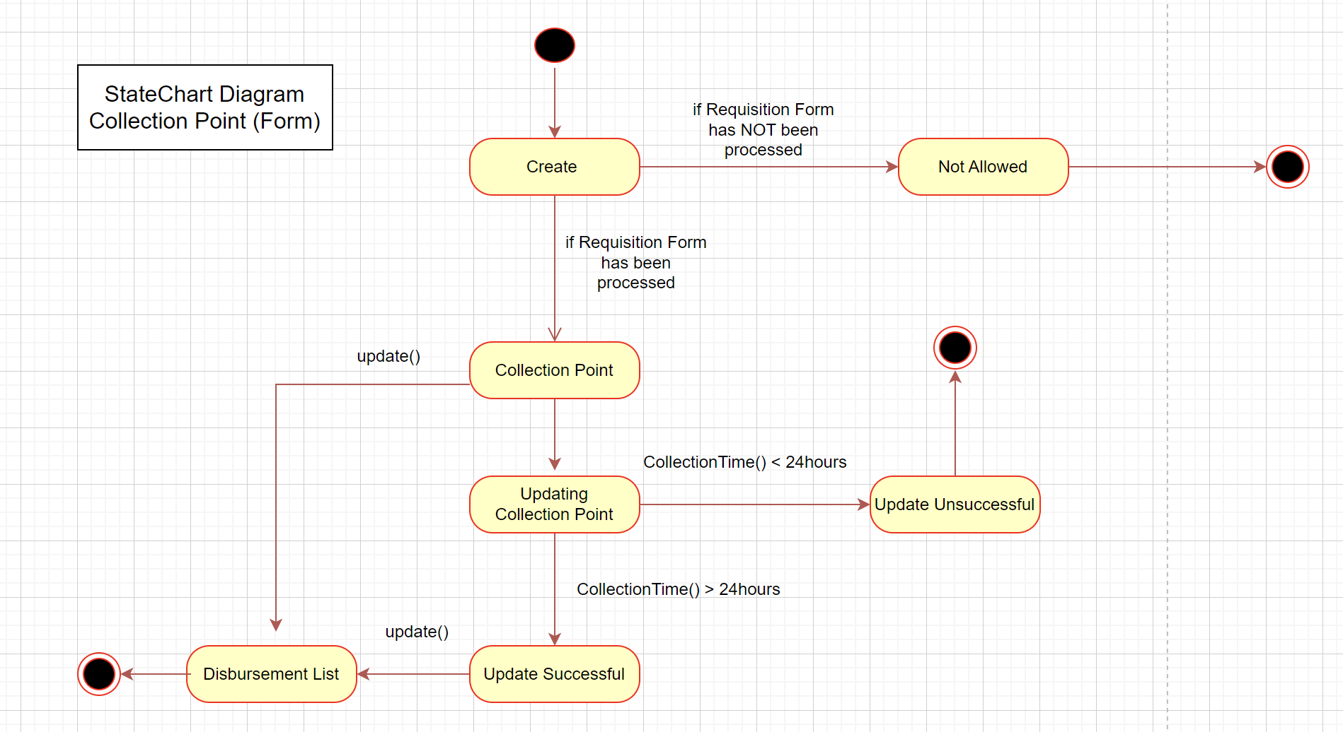

**Use Case: Approve stationery Requisition Form**

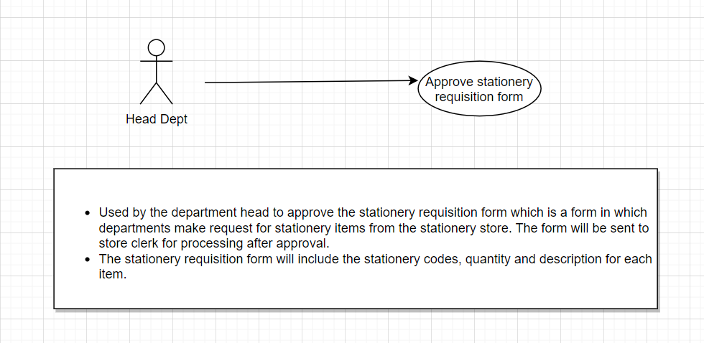

Sequence diagram for Approve Stationery Requisition form

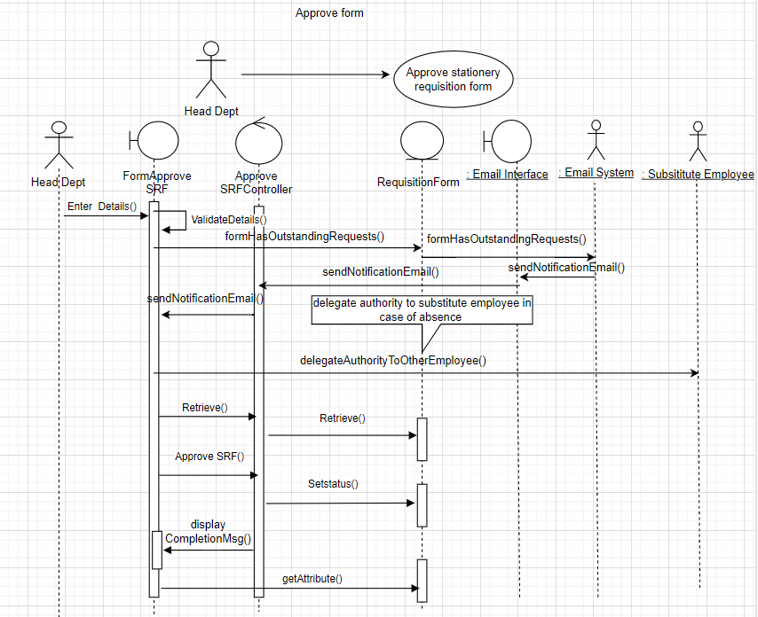

Class diagram for Approve Stationery Requisition form

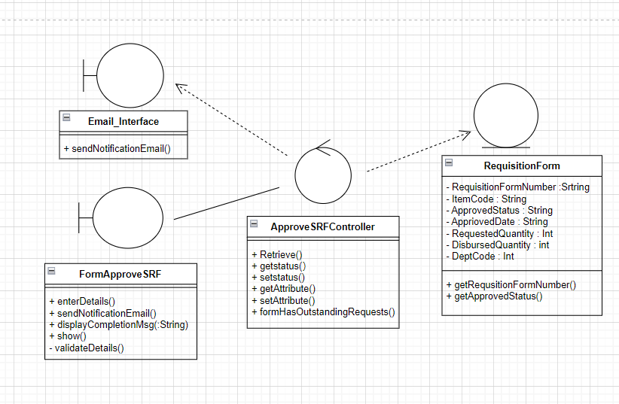

**Use Case: Maintain Inventory List**

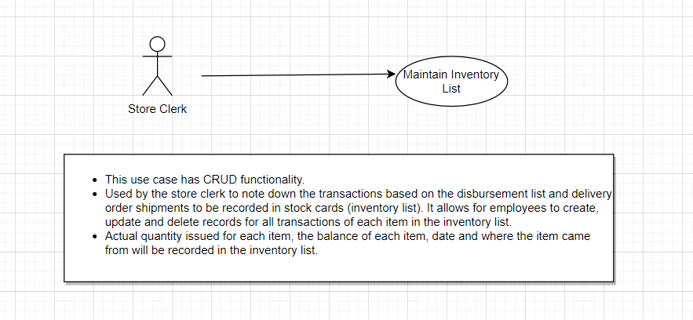

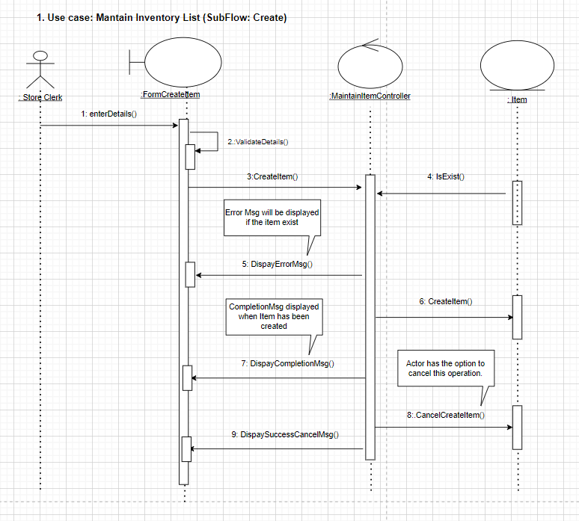

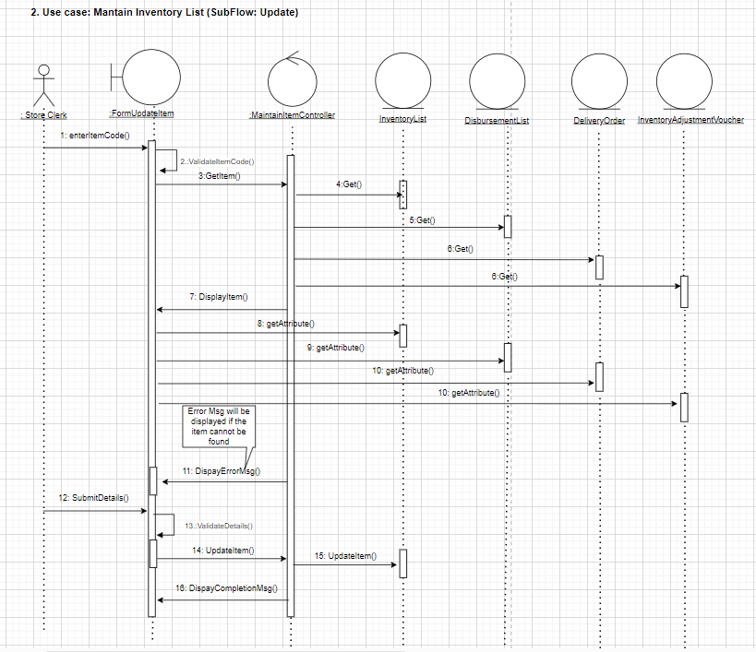

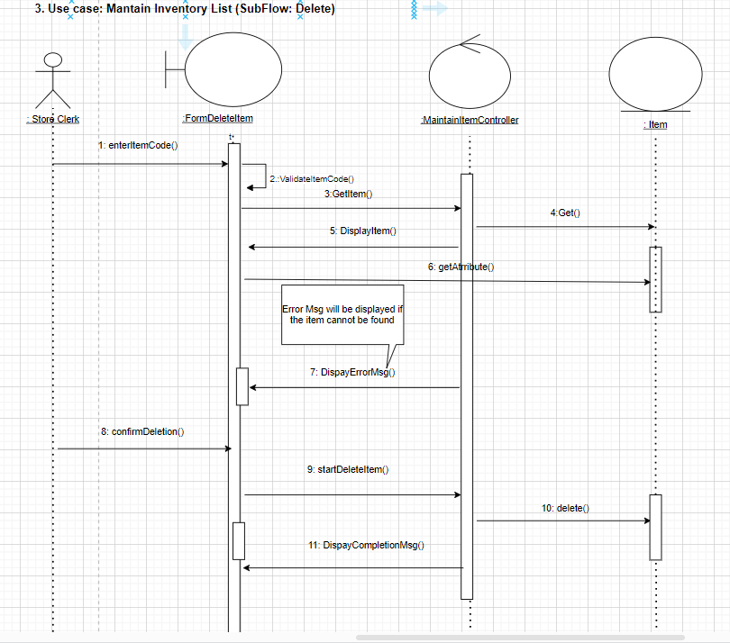

**4. Class Diagram for Use Case: Maintain Inventory List**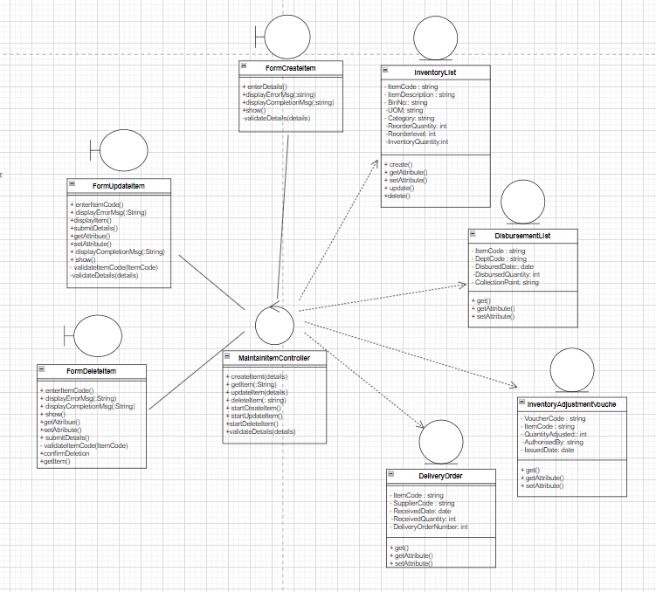

**5. Statechart for Use Case: Maintain Inventory List**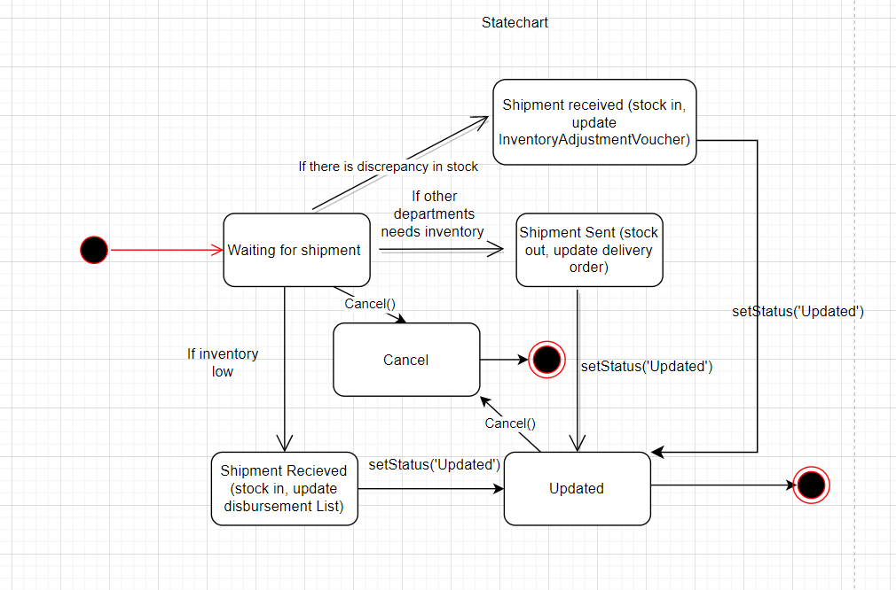

**Use Case: Maintain Disbursement List**

Actual quantity to be delivered (to the same Department) for each item will be noted in the disbursement list.

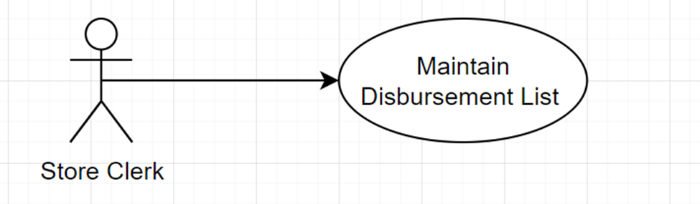

**Flow of Events:**

The use case begins when the store clerk selects the “Maintain Disbursement List” *option from the Main Menu.*

***Basic flow – Create Disbursement List:***

*1.* *Store clerk enters the following details into the create screen of Disbursement List:*

· *Date of disbursement(DDMMYY)*

· *Department code, Collection point*

· *Item code, Quantity*

*2.* *System validates format of details*

*3.* *System retrieves Department name, Representative name, Stationery description*

*4.* *System displays Department name, Representative name, Stationery description*

*5.* *System stores disbursement list with a unique disbursement number*

*6.* *System sets the status of this disbursement list as “Pending for delivery”*

*7.* *System displays a successful message*

***Alternate flow:***

***1.1*** ***Update Disbursement List:***

*1.*  *Store clerk enters disbursement number*

*2.*  *System retrieve disbursement list record*

*3.*  *System display disbursement list*

*4.*  *Store clerk modifies disbursement list*

*5.* *Store clerk submits changes*

*6.* *System validate data format*

*7.*  *System update disbursement list*

*8.* *System displays a successful message*

***1.2***  ***Delete Disbursement List:***

*1.* *Store clerk enters disbursement number*

*2.* *System retrieve disbursement list*

*3.* *System displays disbursement list*

*4.* *Store clerk confirms the delete operation*

*5.* *System delete disbursement list*

*6.* *System display successful message*

***1.3***  ***Print Disbursement List(Print type: print for Delivering):***

*1.* *Store clerk enters disbursement number*

*2.* *System retrieve disbursement list*

*3.* *System displays disbursement list*

*4.* *Store clerk chose print type: print for Delivering*

*5.* *Store clerk confirms the print operation*

*6.* *System sends disbursement list to print*

*7.* *System sets status to “Delivering”*

*8.* *System displays a successful message*

***1.4*** ***Print Disbursement List(Print type: print for Testing):***

*1.* *Store clerk enters disbursement number*

*2.* *System retrieve disbursement list*

*3.* *System displays disbursement list*

*4.* *Store clerk chose print type: print for Testing*

*5.* *Store clerk confirms the print operation*

*6.* *System sends disbursement list to print*

*7.* *System displays a successful message*

***1.5***  ***Disbursement List Exists***

*(Create Disbursement List flow) System finds an existing disbursement list with the same disbursement date and department code.*

*1.* *System displays an error message, “Already has a pending delivery list on this day for this department. Confirm to create another disbursement list(more than one delivery requests)? ”*

*2.* *Store clerk can either click to create a new disbursement list, or cancel the operation at which the use case terminates*

***1.6***  ***Disbursement List Not Exists***

*(Update, Delete or two types of Print Disbursement List flow) System could not locate the disbursement list.*

*1.* *System displays an error message, “Disbursement List Not Found”*

*2.* *Store clerk can either re-enter disbursement number, or cancel the operation at which the use case terminates*

***1.7*** ***Disbursement List Status Changed***

*(Update, Delete or Print Disbursement List(Print type: print for delivering) flow) The statues of this disbursement list is not “Pending for delivery”. After printing, status will be “Delivering”. After representative employee signs, status will be “Successfully delivered”)*

*1.* *System display an error message, “Status changed. Can not modify or print.”*

*Store clerk can either prompt a operation request to store supervisor (cannot modify disbursement list until supervisor approve), or cancel the operation at which the use case terminates*

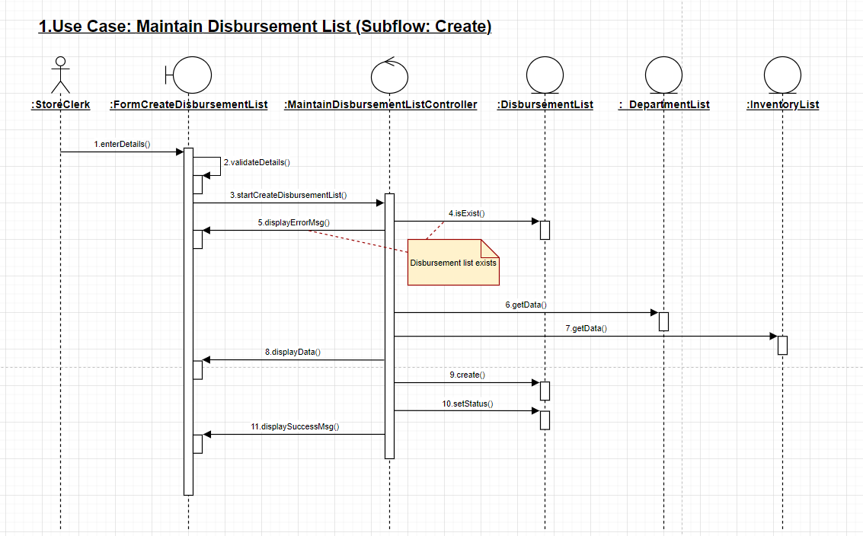

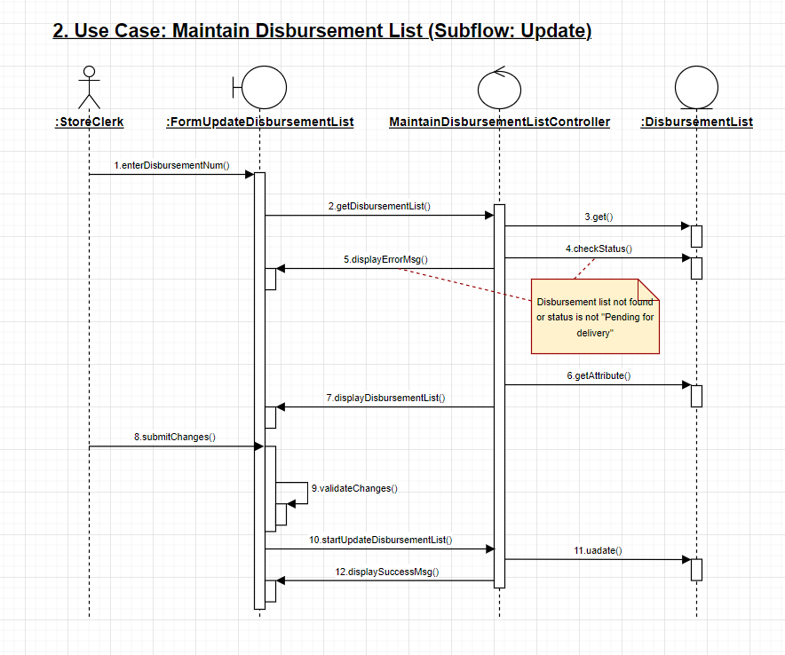

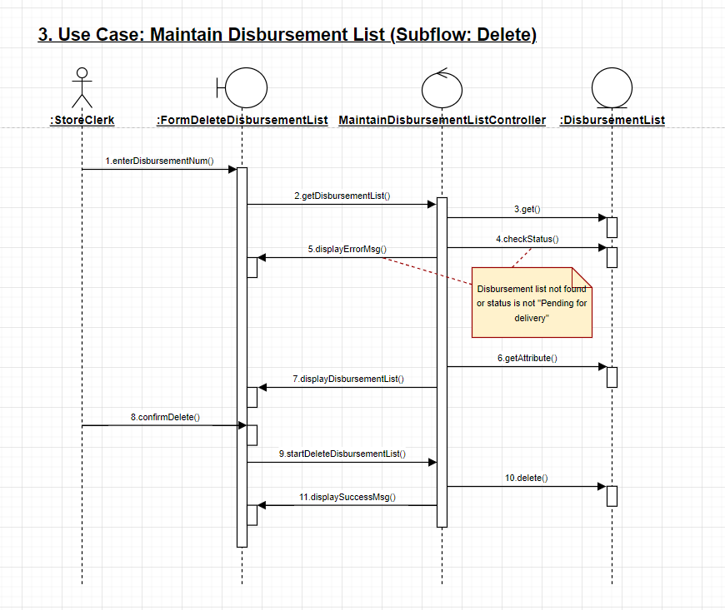

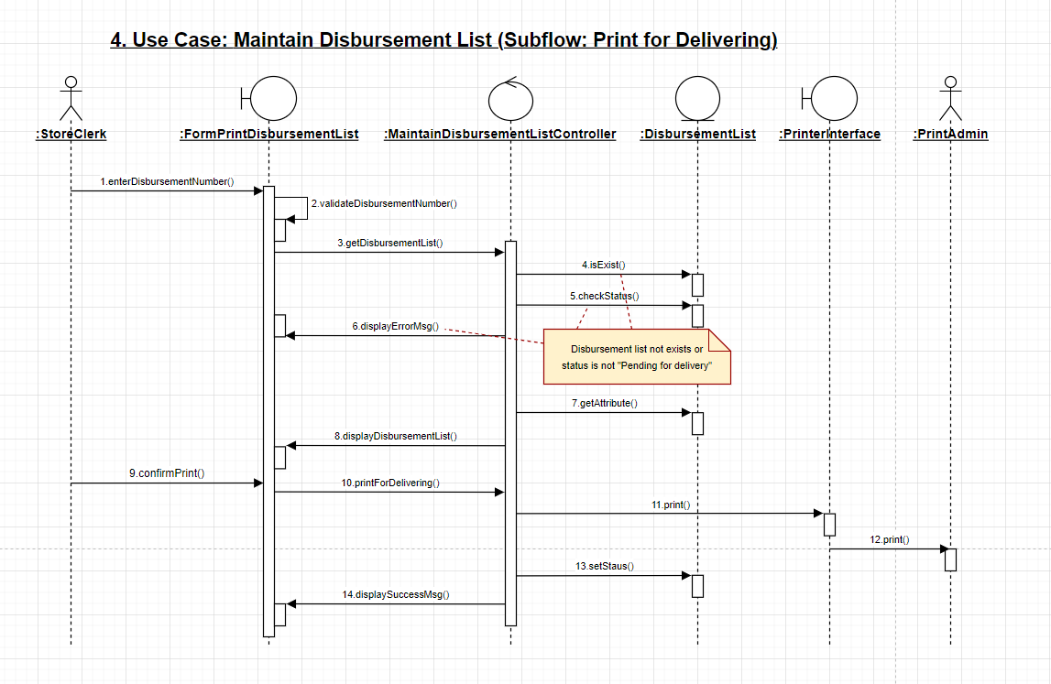

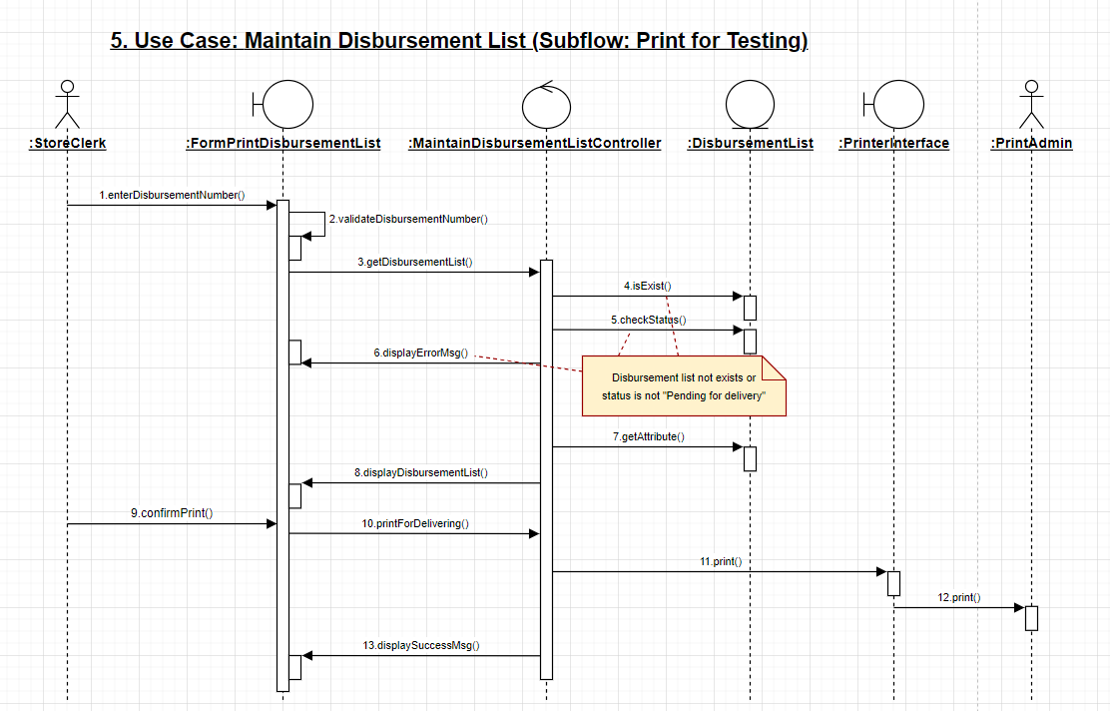

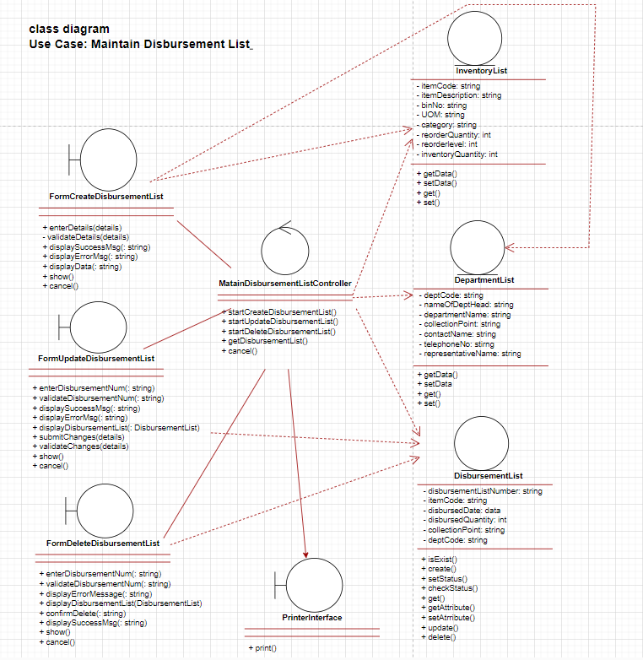

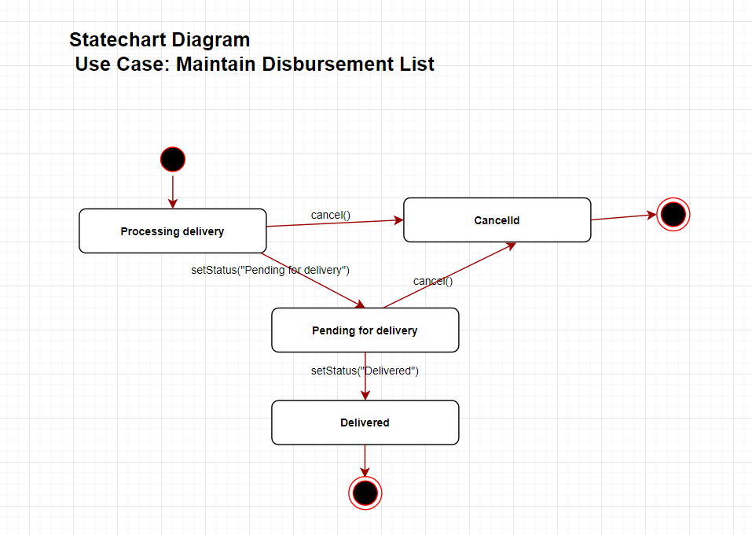

**Use Case: Maintain Purchase Order**

Store clerk will fill up the purchase order Form depending on the stock level of the items every two weeks.

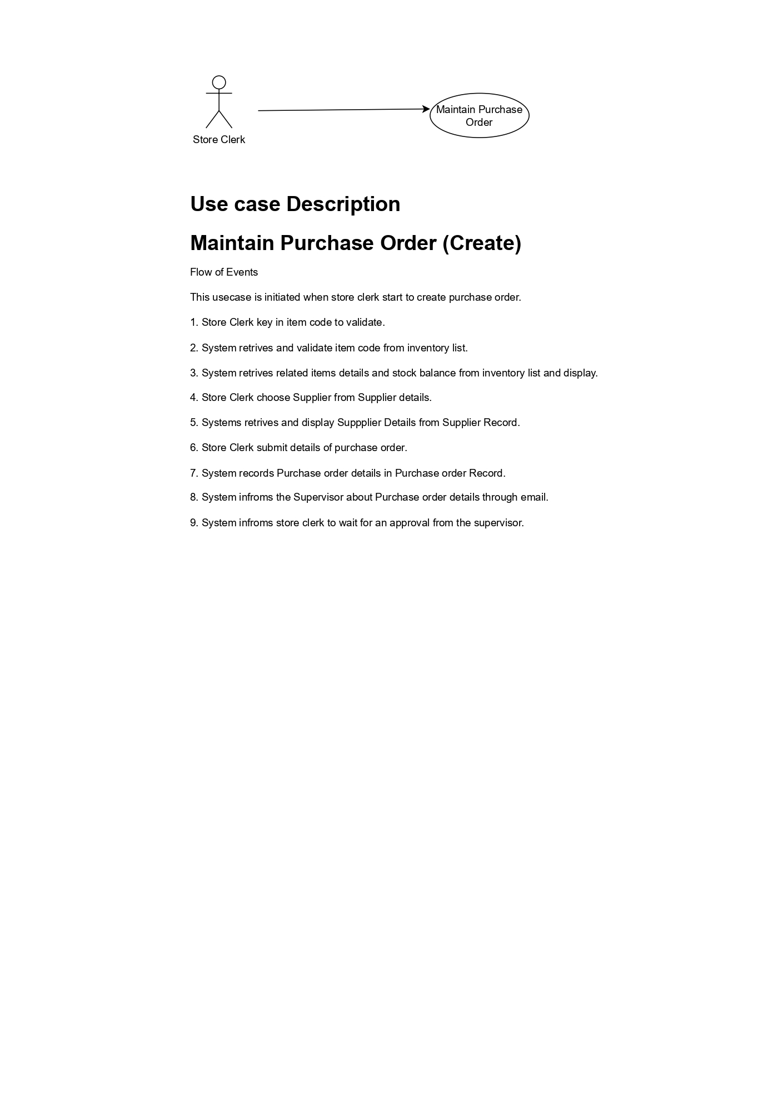

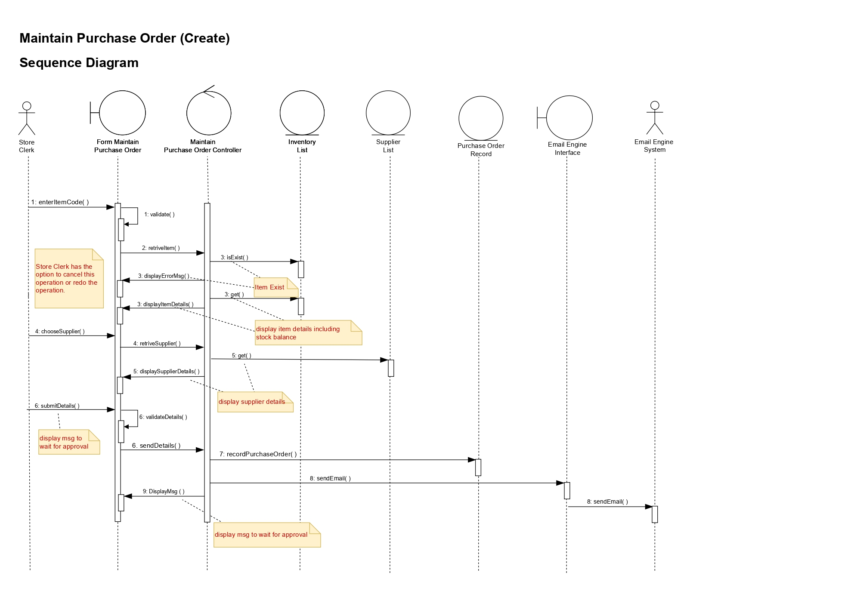

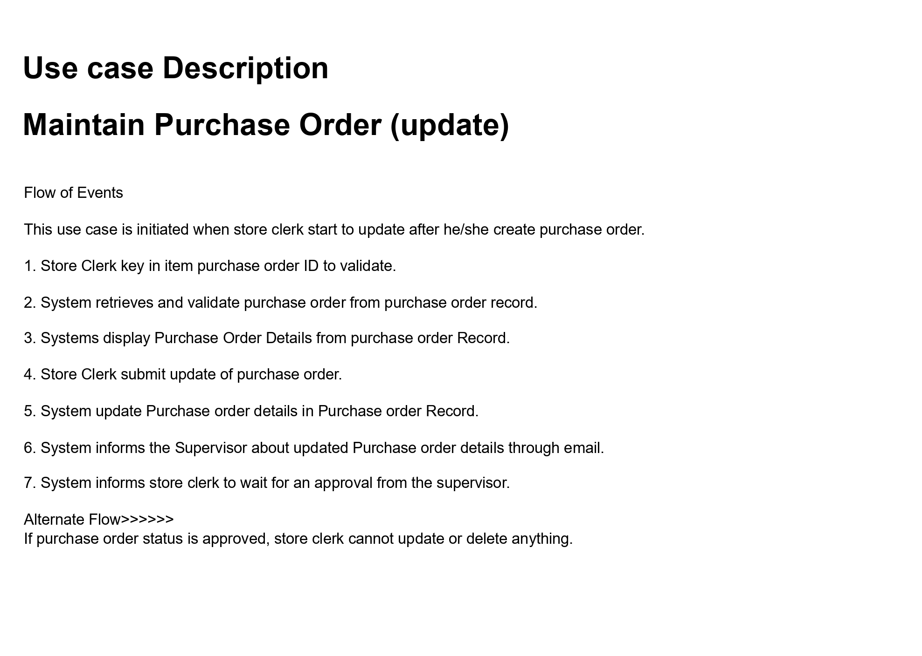

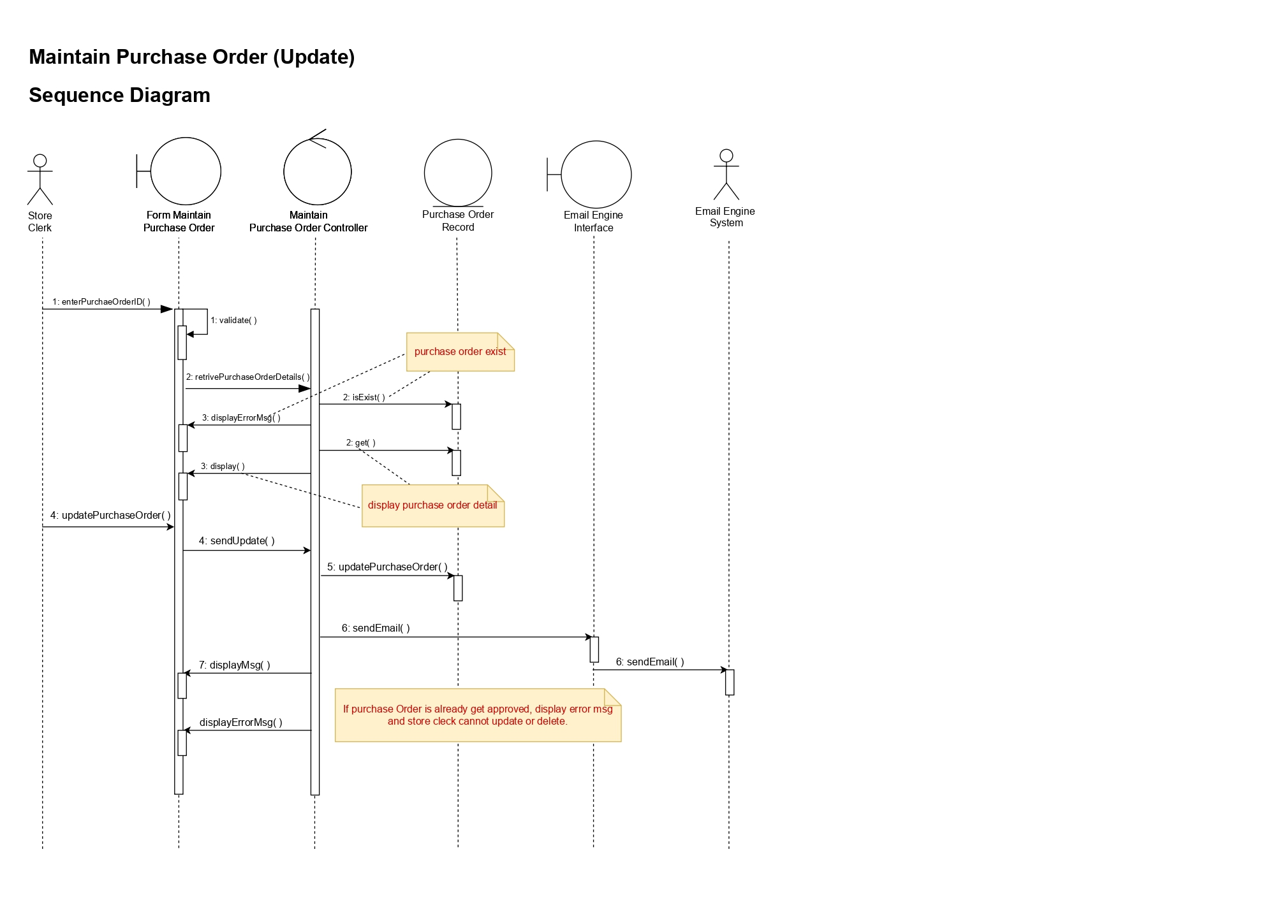

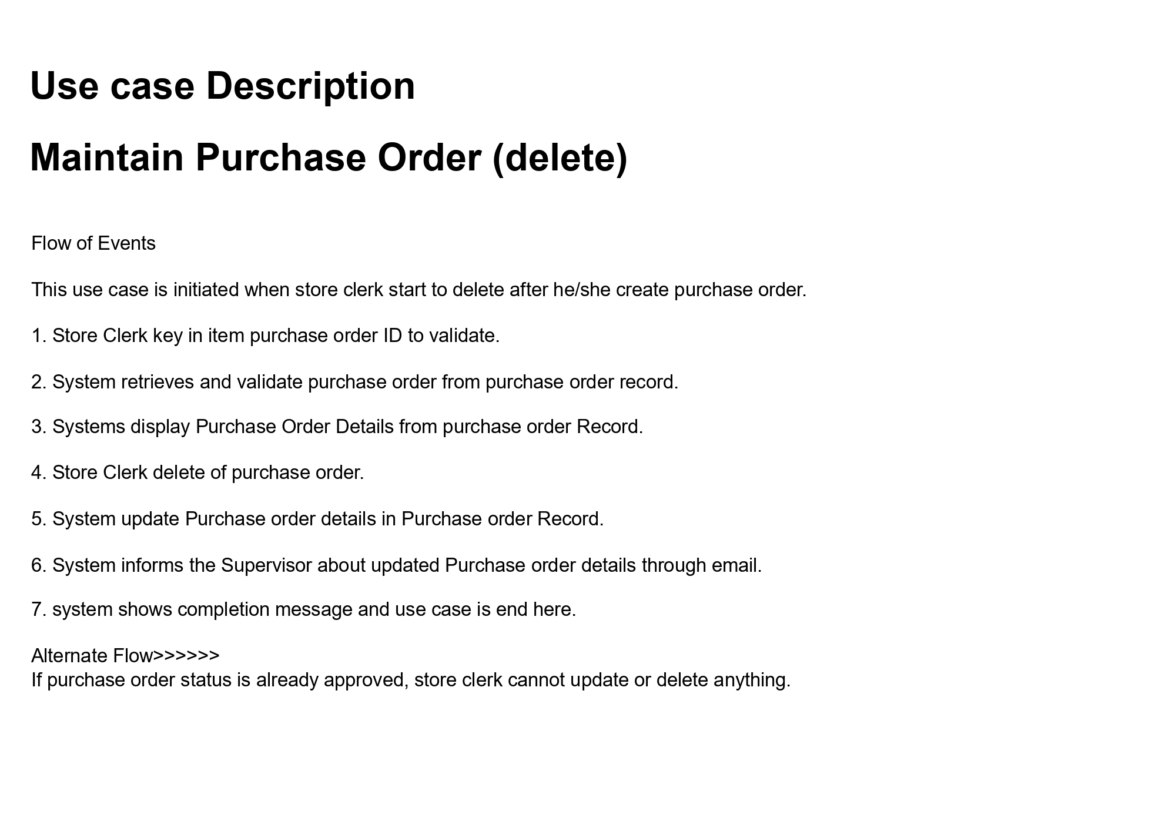

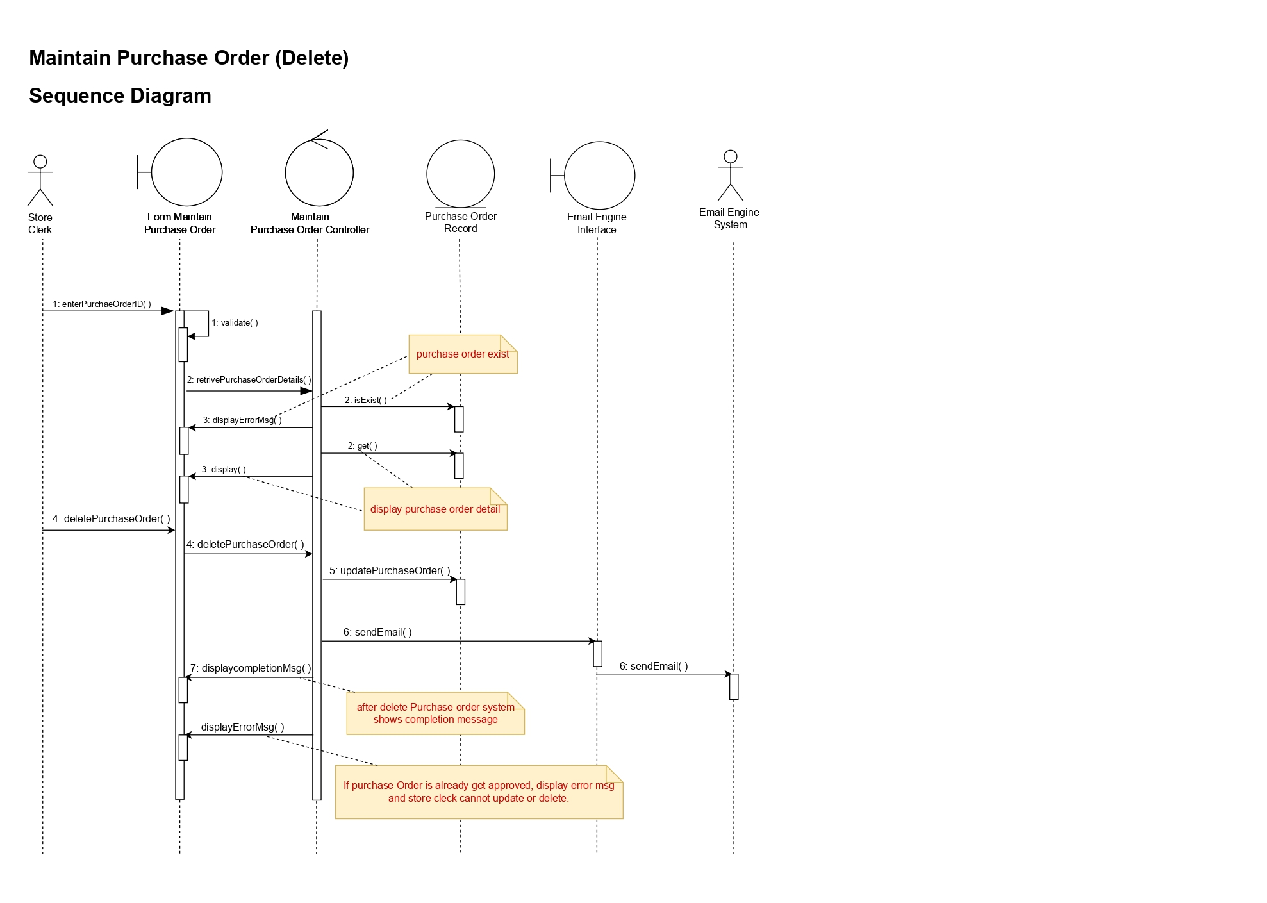

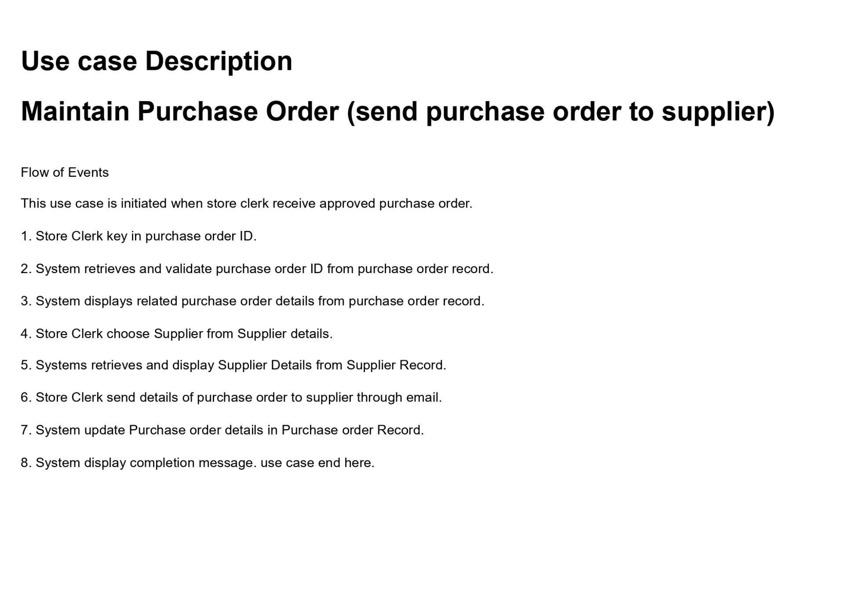

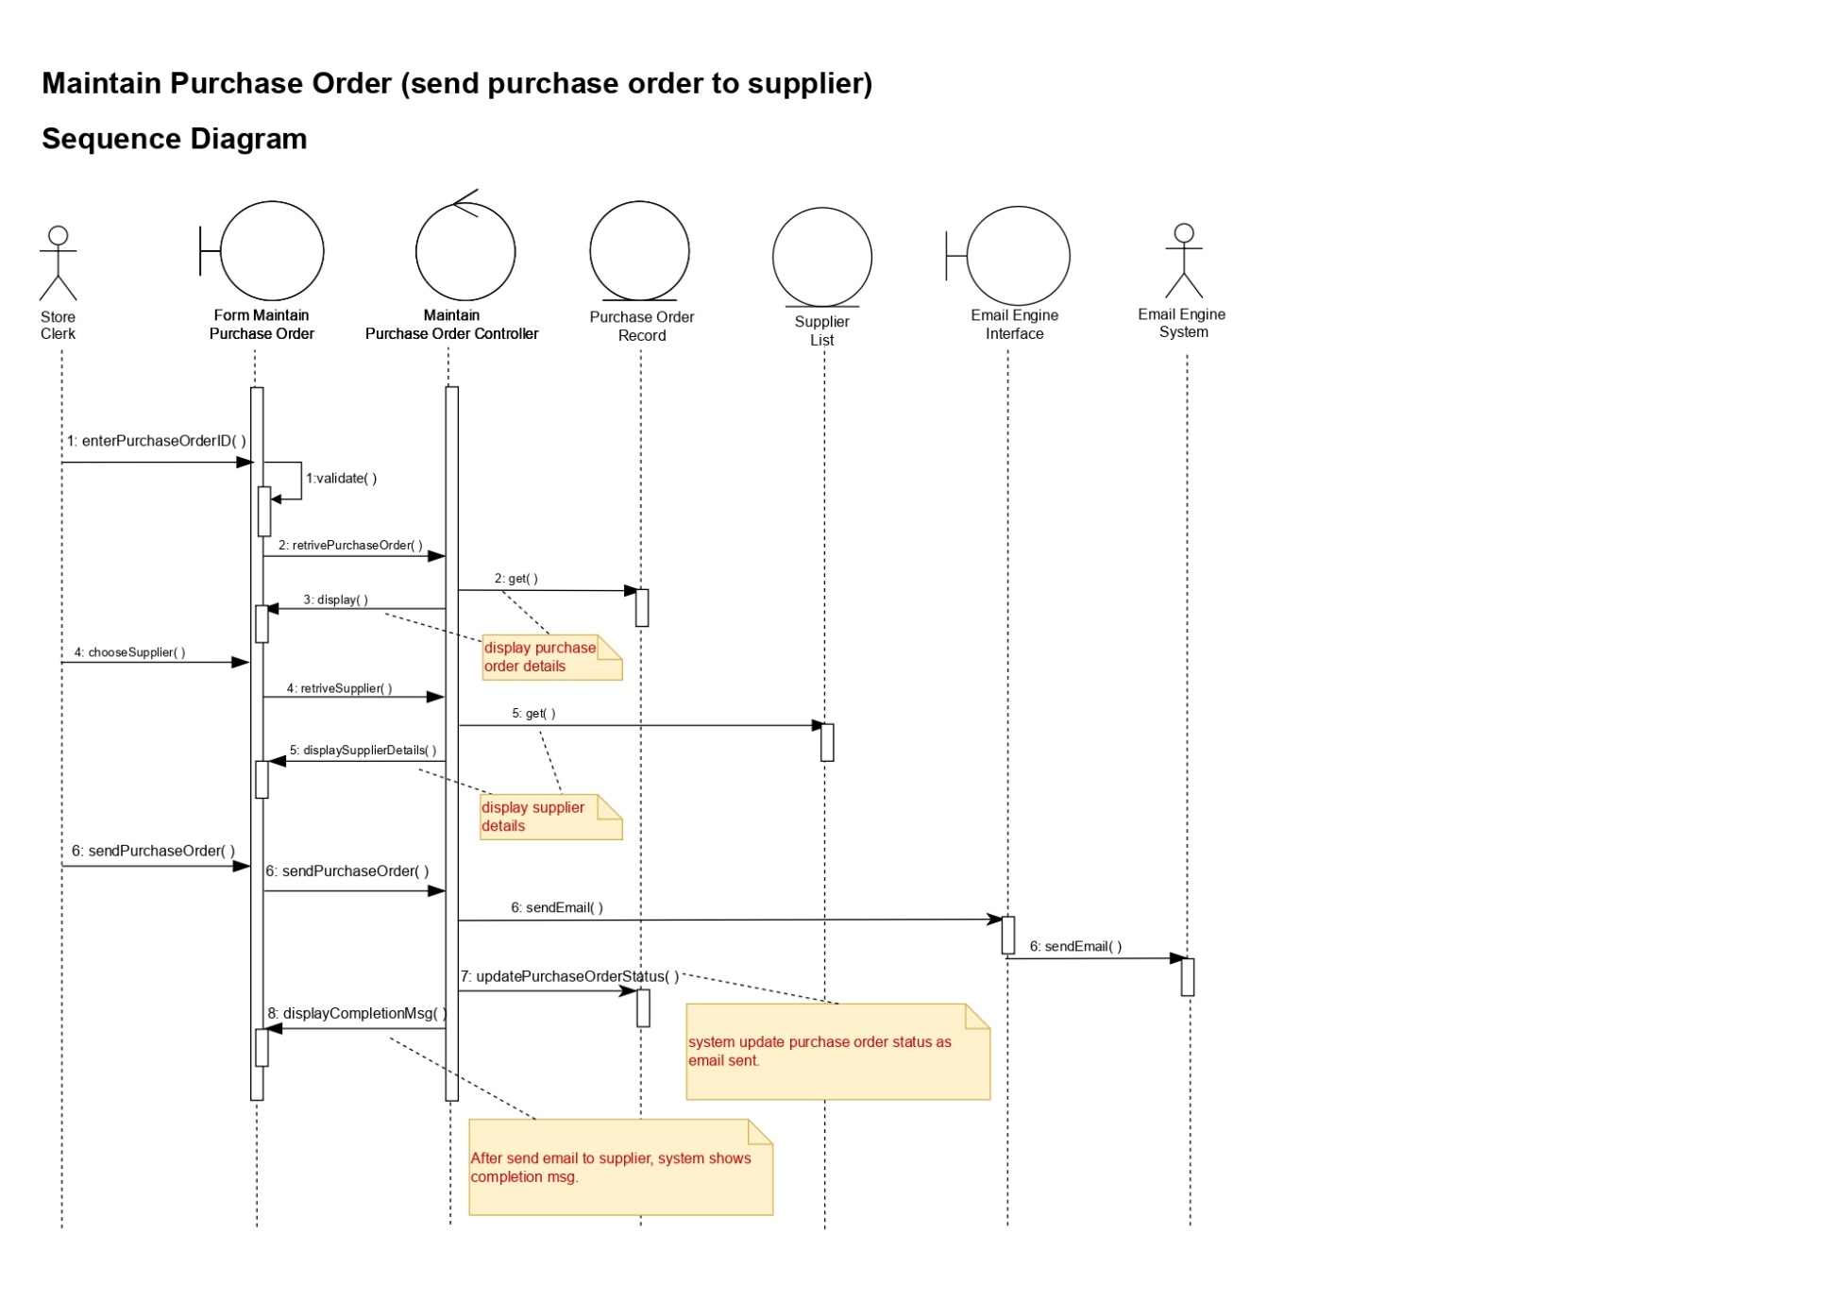

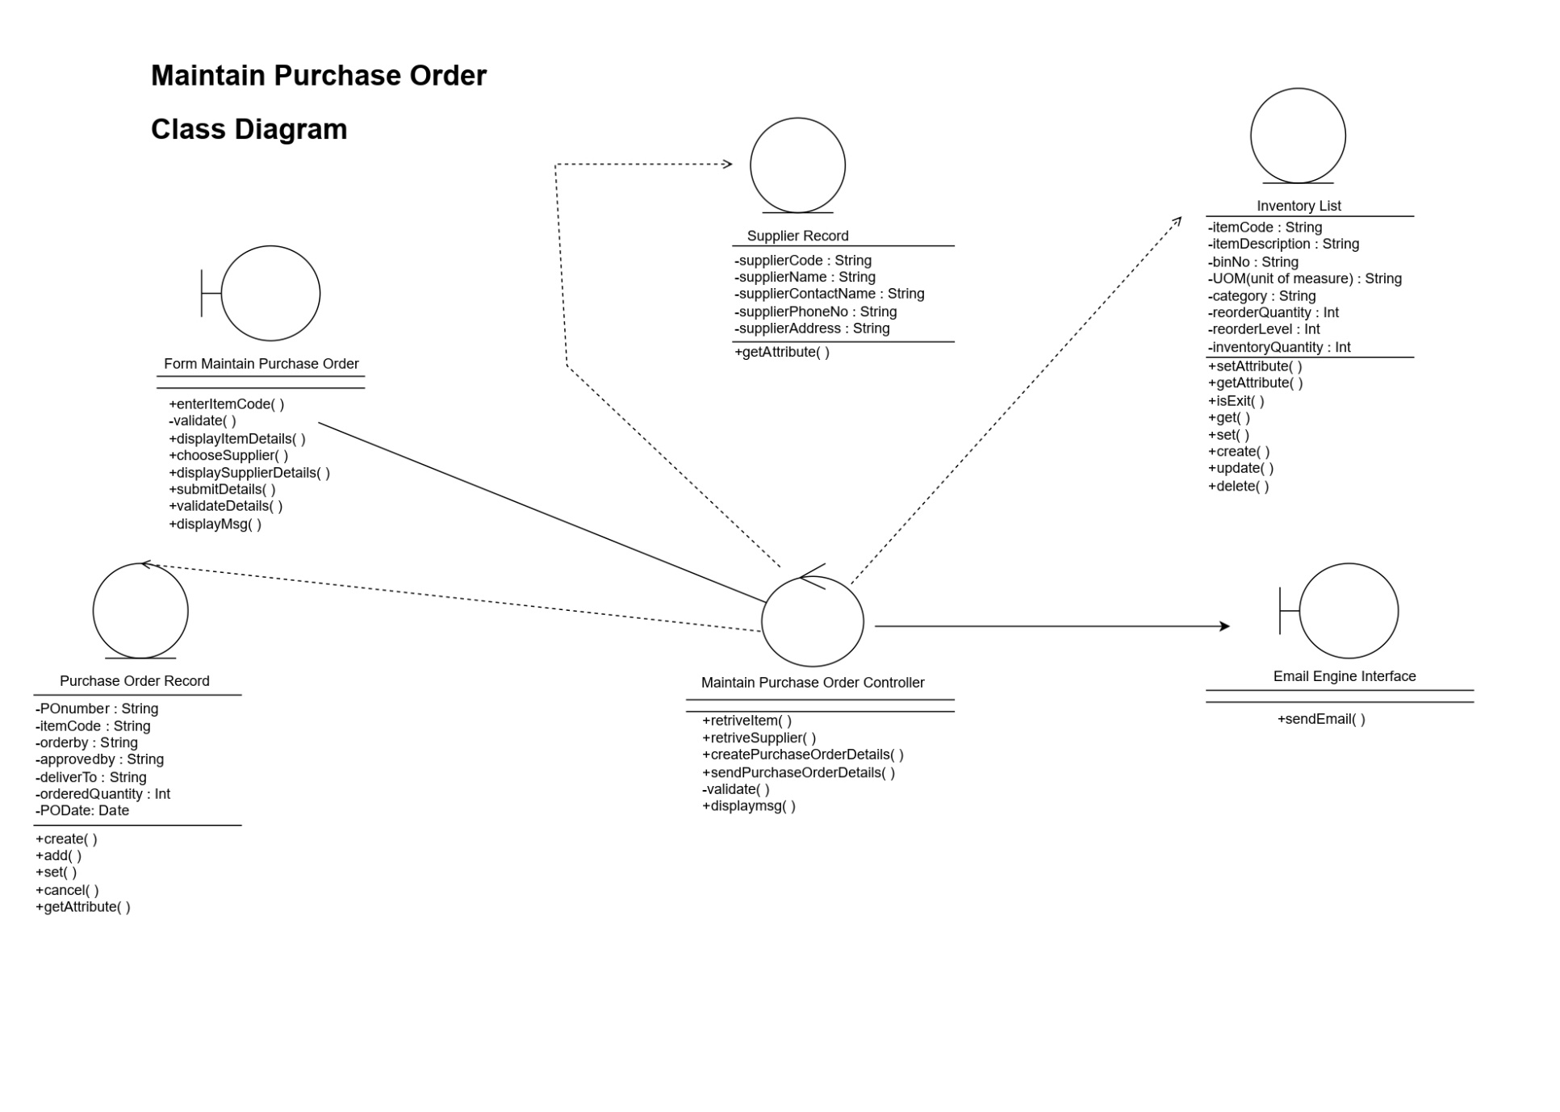

**Use Case: Approve Purchase Order**

Alert the Store Supervisor to approve the pending Purchase Order.

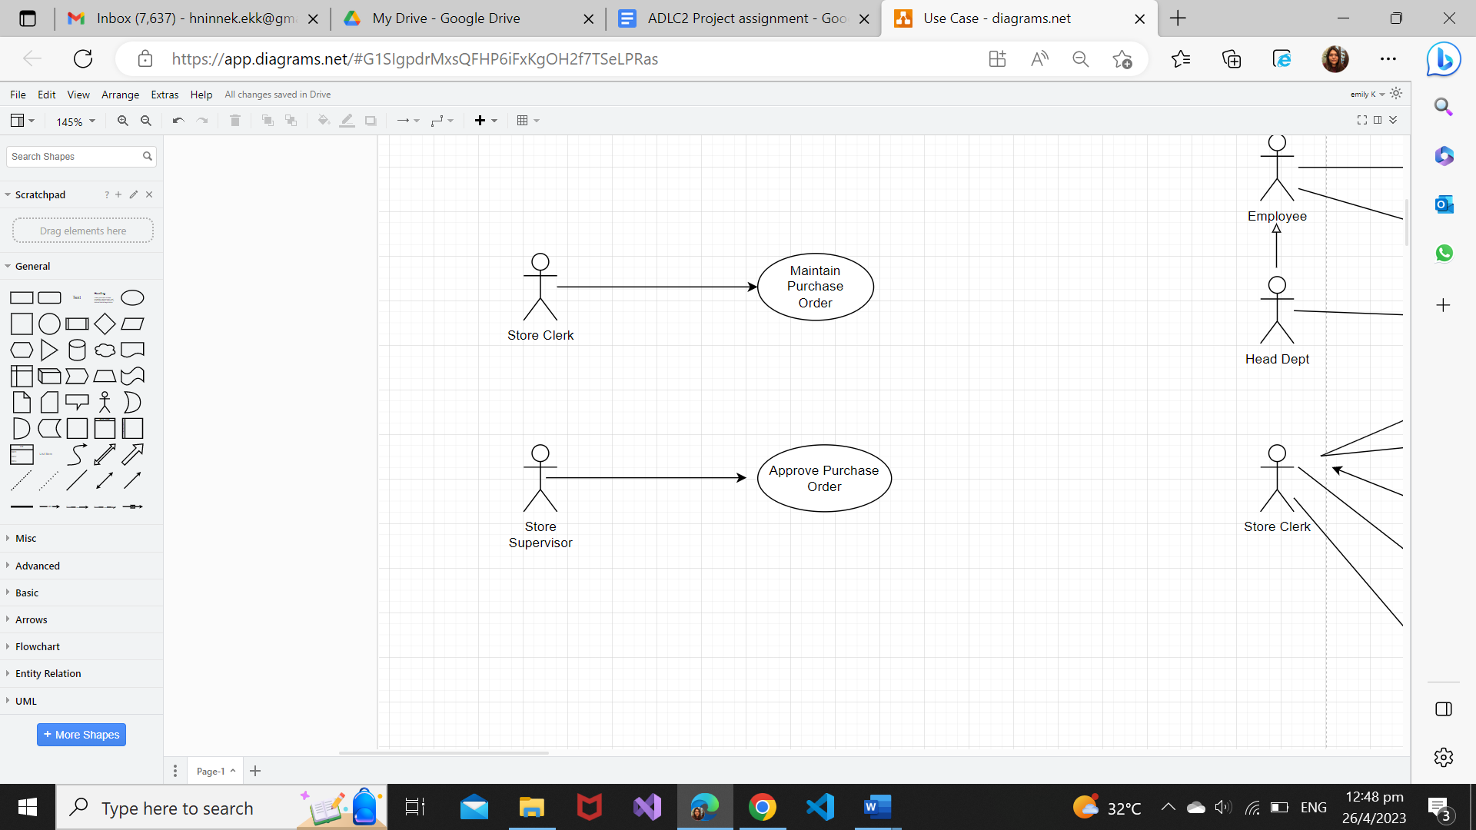

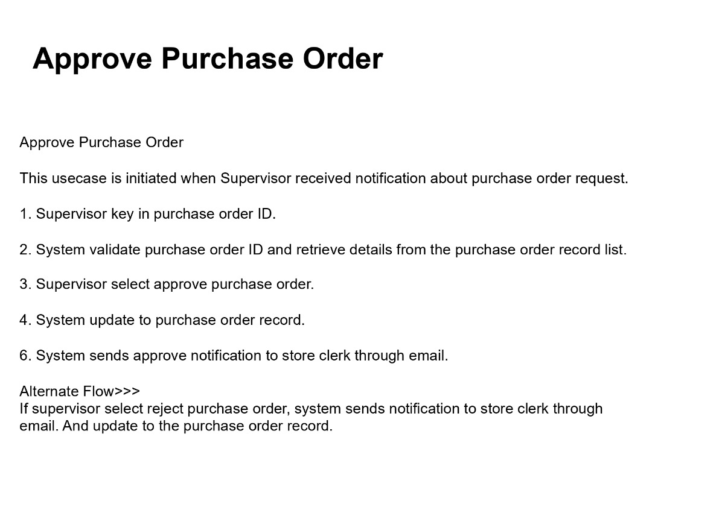

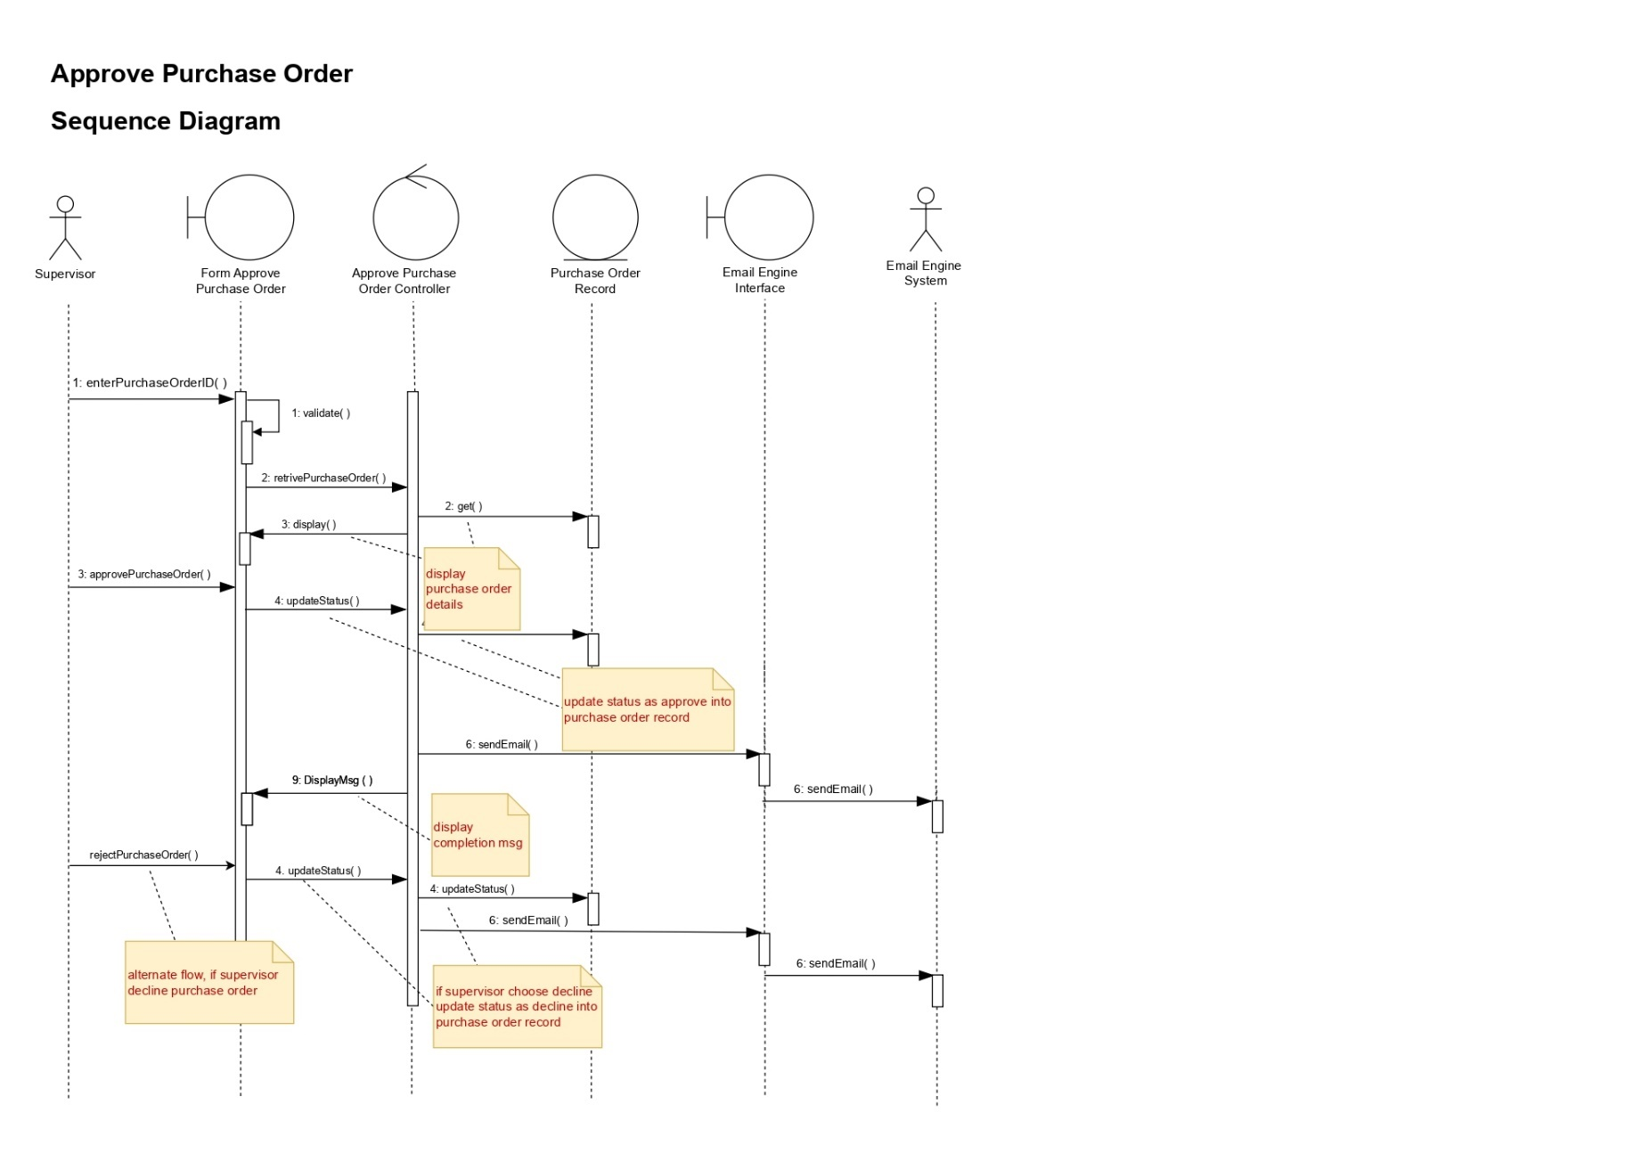

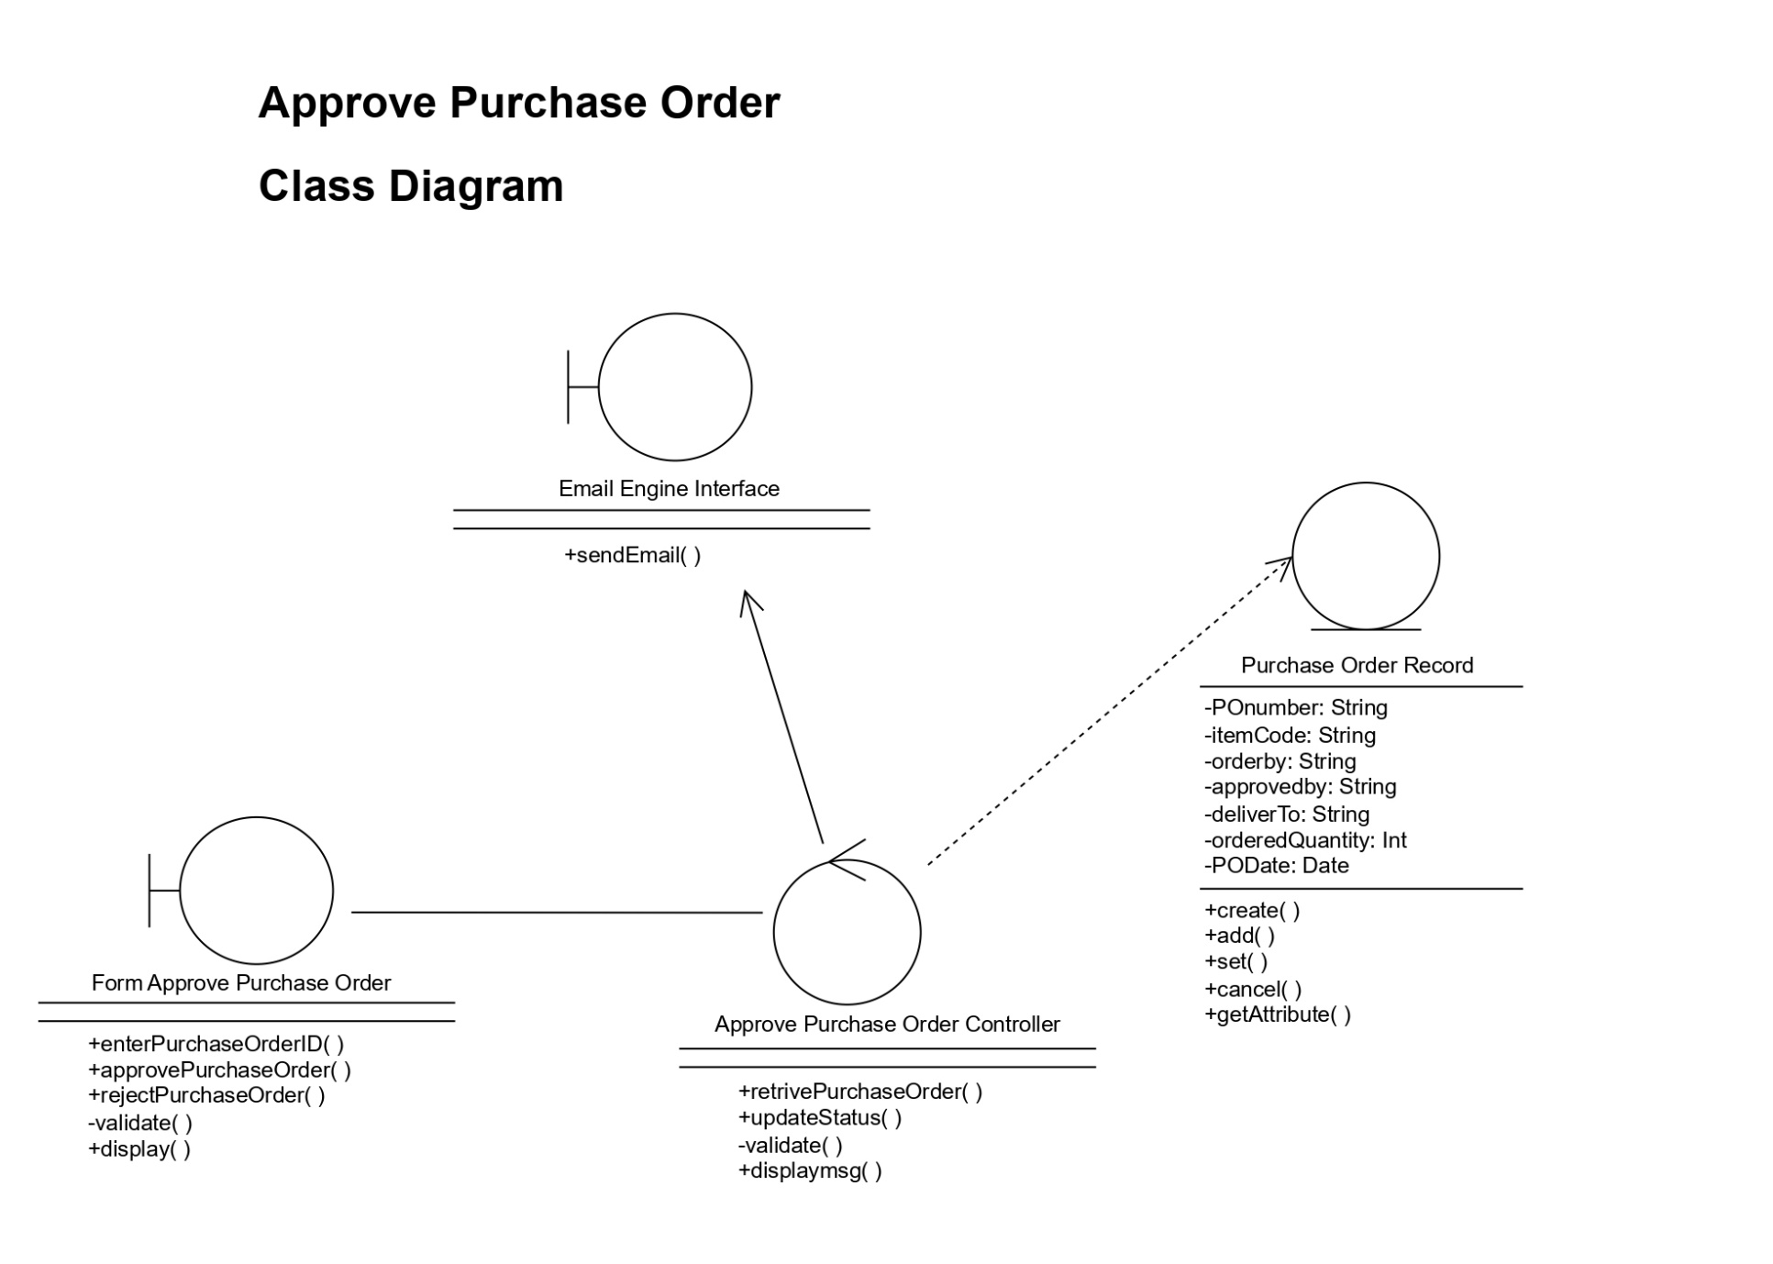

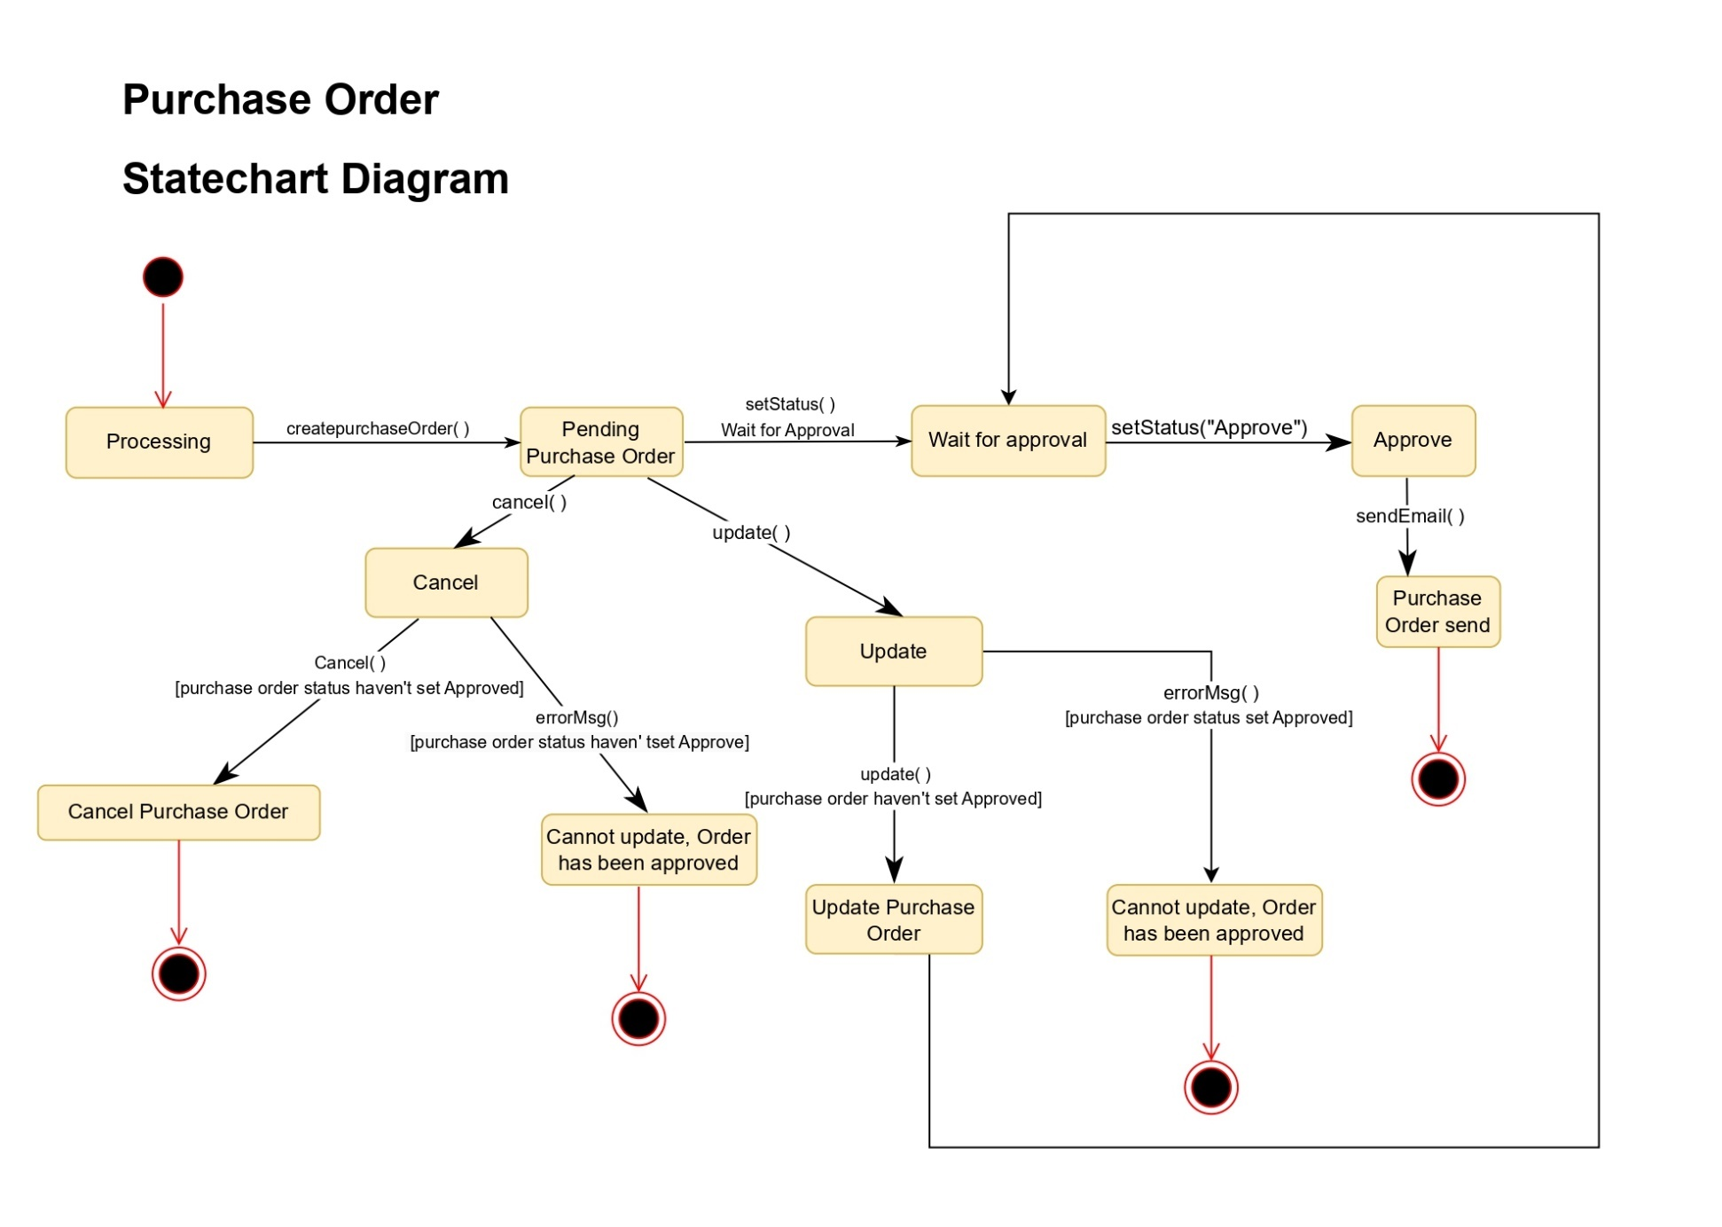

**Use Case: Issue Stock Adjustment Voucher**

The store supervisor will issue a stock adjustment voucher for anything under $250 per item adjustment.

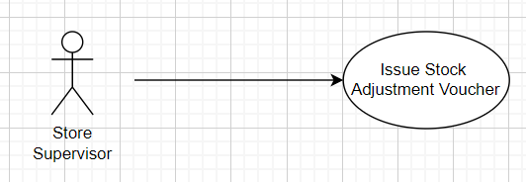

**Issue Stock Adjustment Voucher : Sequence Diagram**

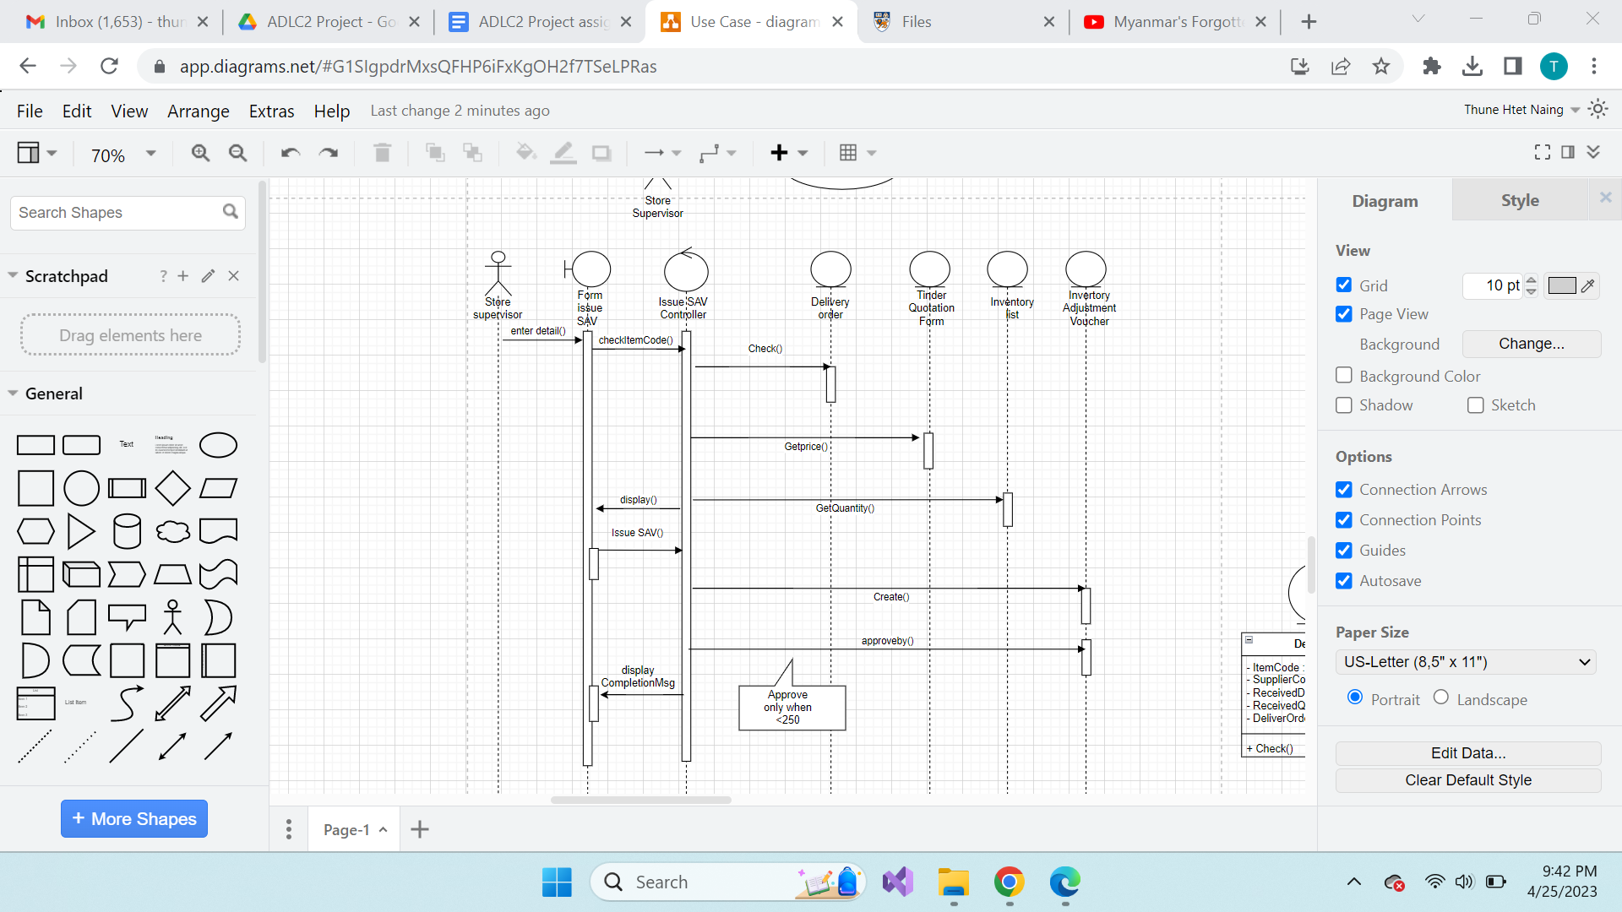

**Issue Stock Adjustment Voucher : Class Diagram**

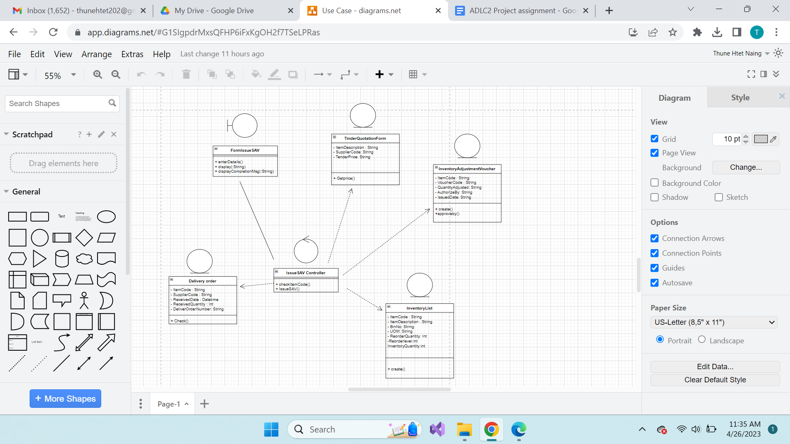

**Use Case: Approve Stock Adjustment Voucher**

The store manager approves and issue the stock adjustment voucher that is above $250.

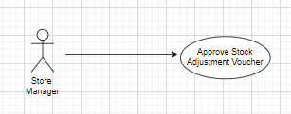

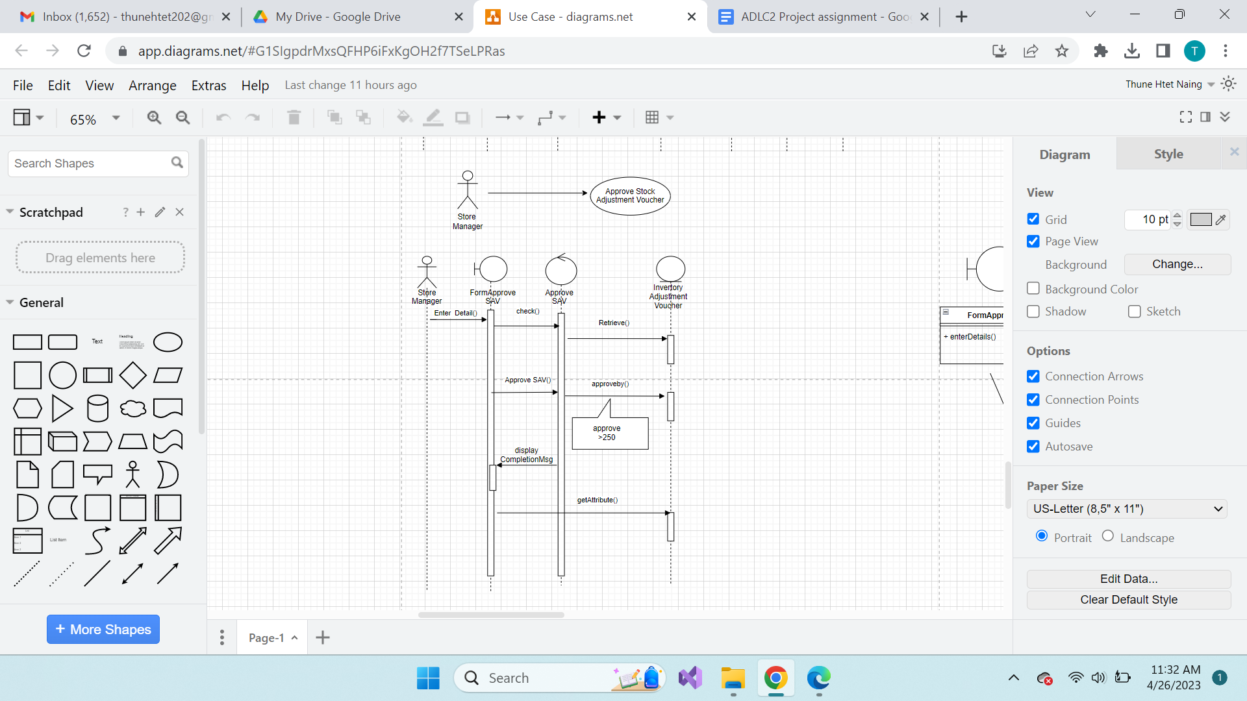

**Approve Stock Adjustment Voucher**

**Sequence Diagram**

**Approve Stock Adjustment Voucher : Class Diagram**

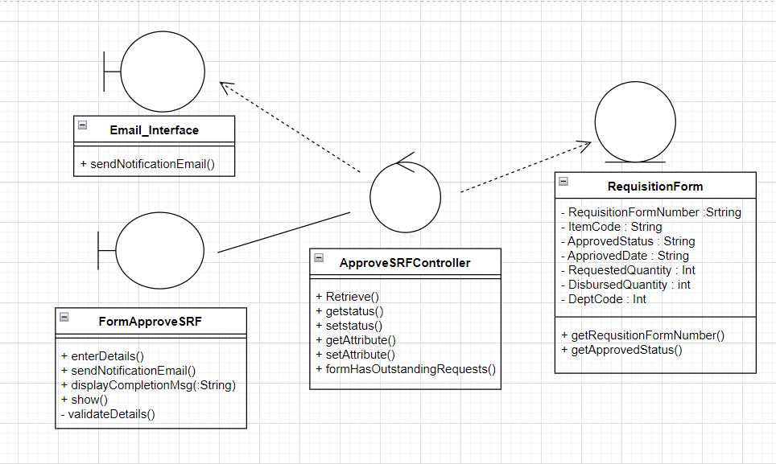

**Use Case: View Reports**

Sales report including the amount of stationery ordered grouped by categories and stationery requisition trend of each department.

Report to be generated with current and past 2 months.

Store manager and store supervisor are authorised to see reports.

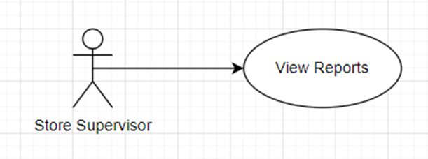

**Flows and Events:**

The use case begins when the manager selects the “Report” *option from the Main Menu.*

Basic flow:

For retrieve total amount analysis report

1. System displays total amount analysis report in current month and past 2 months

2. Manager can select any month within past 2 years to retrieve and compare data

3. System display 3 months data analysis

Alternate flows:

1.1 Retrieve stationery requisition trend report

1. System displays stationery requisition trend of each department in current month and past 2 months

2. Manager can select any month within past 2 years to retrieve and compare data

3. System display 3 months data analysis

1.2 Retrieve stock item movements trend report

1. System displays stock item movements trend in current month and past 2 months

2. Manager can select any month within past 2 years to retrieve and compare data

3. System display 3 months data analysis

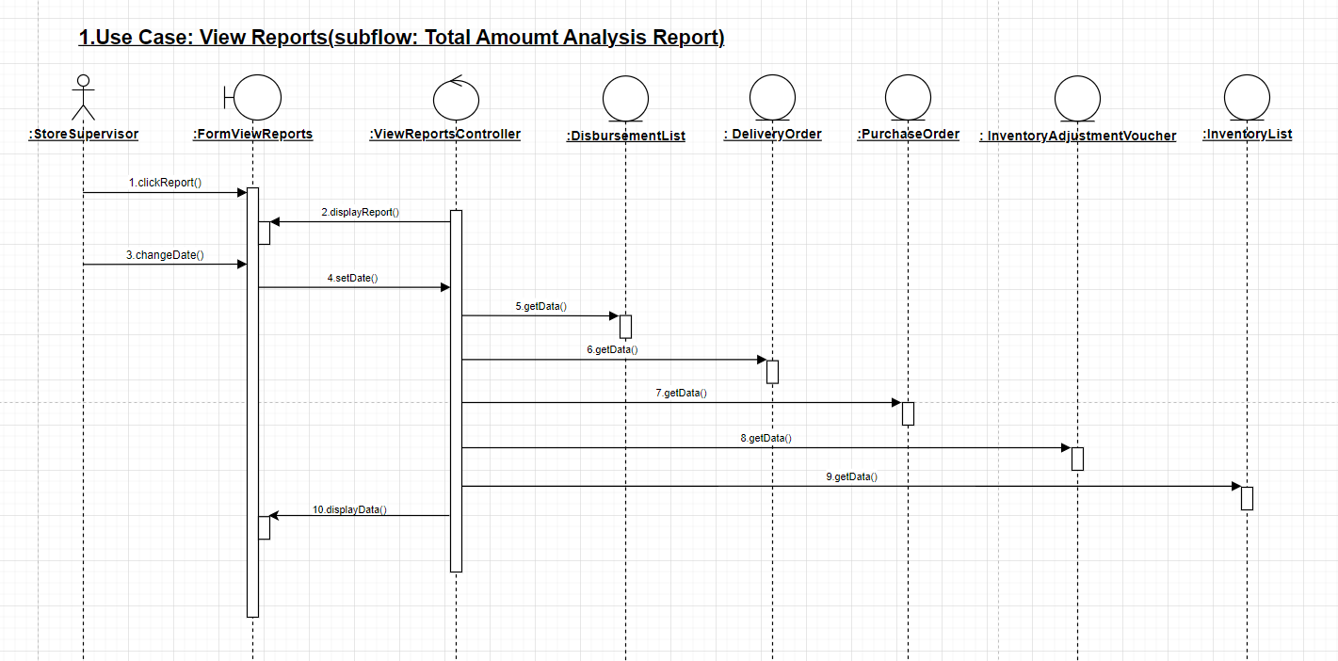

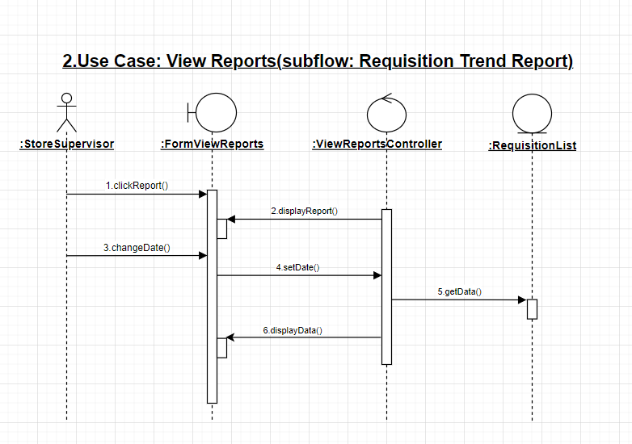

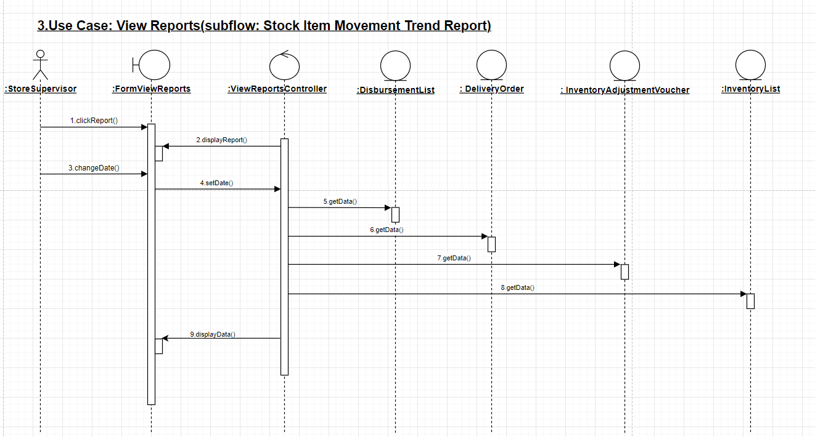

**Use Case: Maintain List**

(includes Supplier, Department, Price)

Annually (or as needed), Store Clerk can go to the system to update the various list in the database.

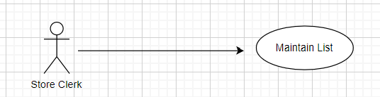

***Basic Flow: (SubFlow: Create)***

1. *StoreClerk select the type of forms and enters details of of the form*
2. *System Validates the format of StoreClerk details*
   1. *Supplier Forms (Link information to Dictionary)*
   2. *Department Forms (Link information to Dictionary)*
   3. *Price Forms (Link information to Dictionary)*
3. *If there are no existing records*
4. *System creates the information*
5. *System Displays Successful message*

***Alternative Flow:***

*For Step 2, if data already exist, the information in the form,*

*An error message will be thrown*

***Basic Flow: (SubFlow: Update)***

1. *StoreClerk select the type of forms and enters details of of the form*
2. *System Validates the format of StoreClerk details*
   1. *Supplier Forms (Link information to Dictionary)*
   2. *Department Forms (Link information to Dictionary)*
   3. *Price Forms (Link information to Dictionary)*
3. *System Retrieve the form with the information of the existing data*
4. *System Updates the information*
5. *System Displays Successful message*

***Alternative Flow:***

*For Step 2, if unable to locate the information in the form,*

*An error message will be thrown*

***Basic Flow: (SubFlow: Delete)***

1. *StoreClerk select the type of forms and enters details of of the form*
2. *System Validates the format of StoreClerk details*
   1. *Supplier Forms (Link information to Dictionary)*
   2. *Department Forms (Link information to Dictionary)*
   3. *Price Forms (Link information to Dictionary)*
3. *System Retrieve the form with the information of the existing data*
4. *System Deletes the information*
5. *System Displays Successful message*

***Alternative Flow:***

*For Step 2, if unable to locate the information in the form, An error message will be thrown*

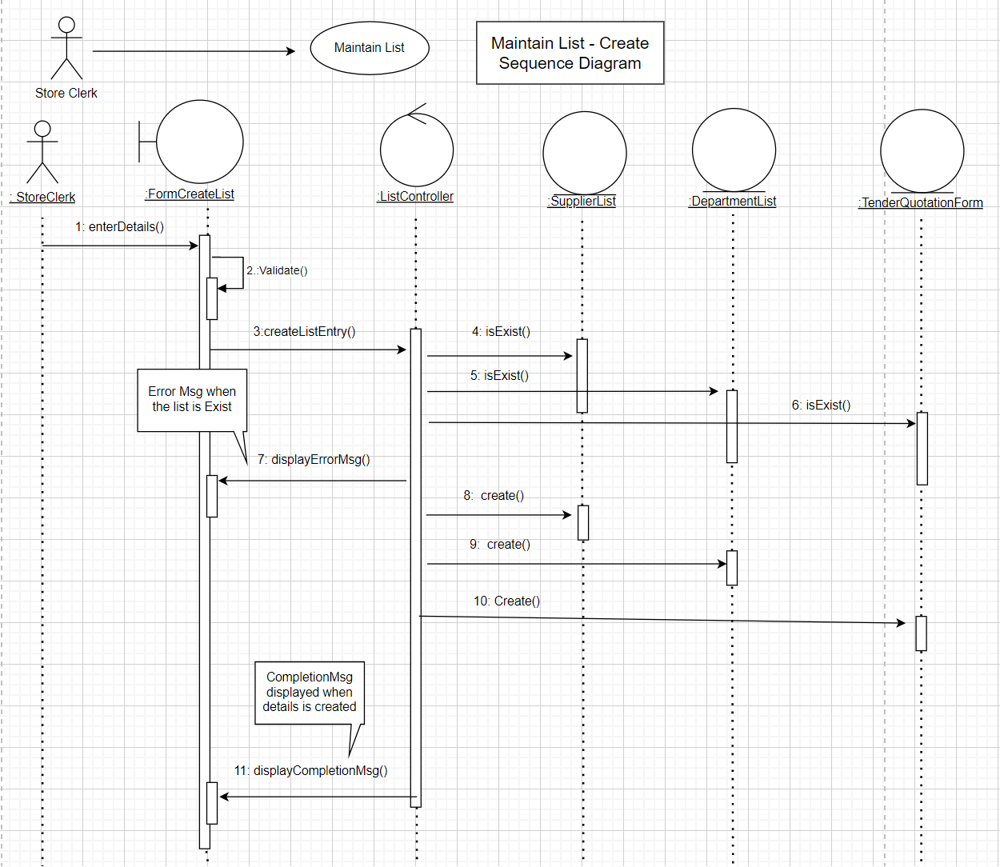

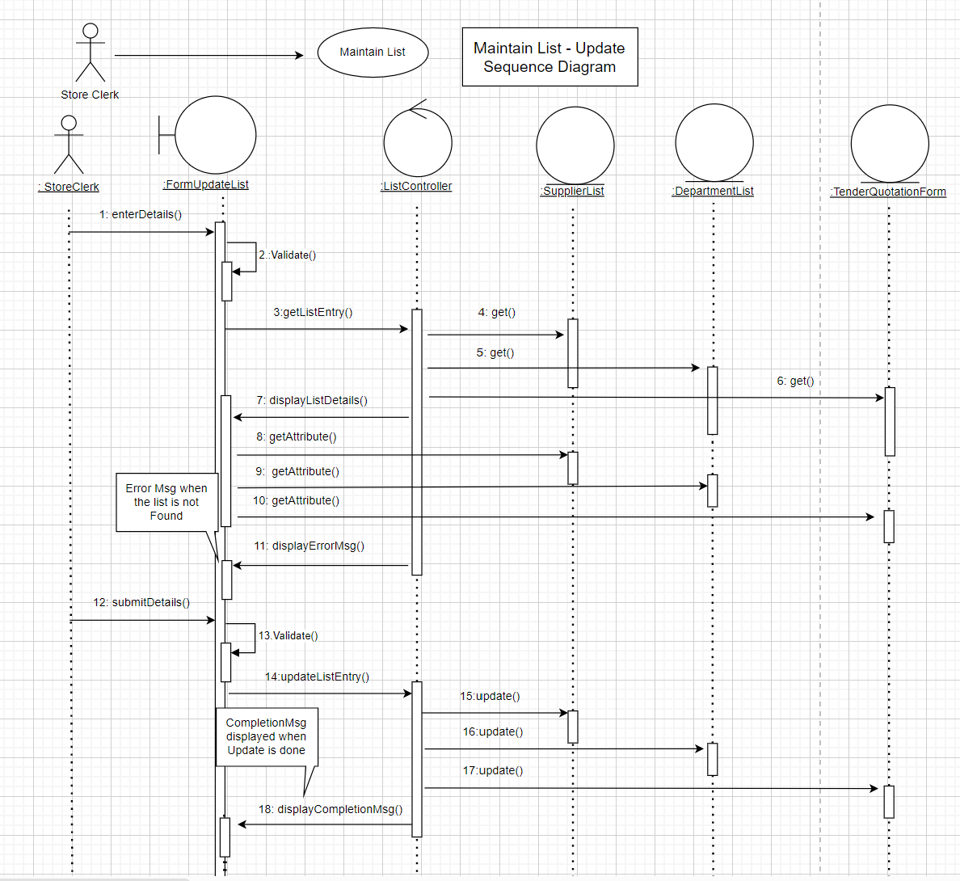

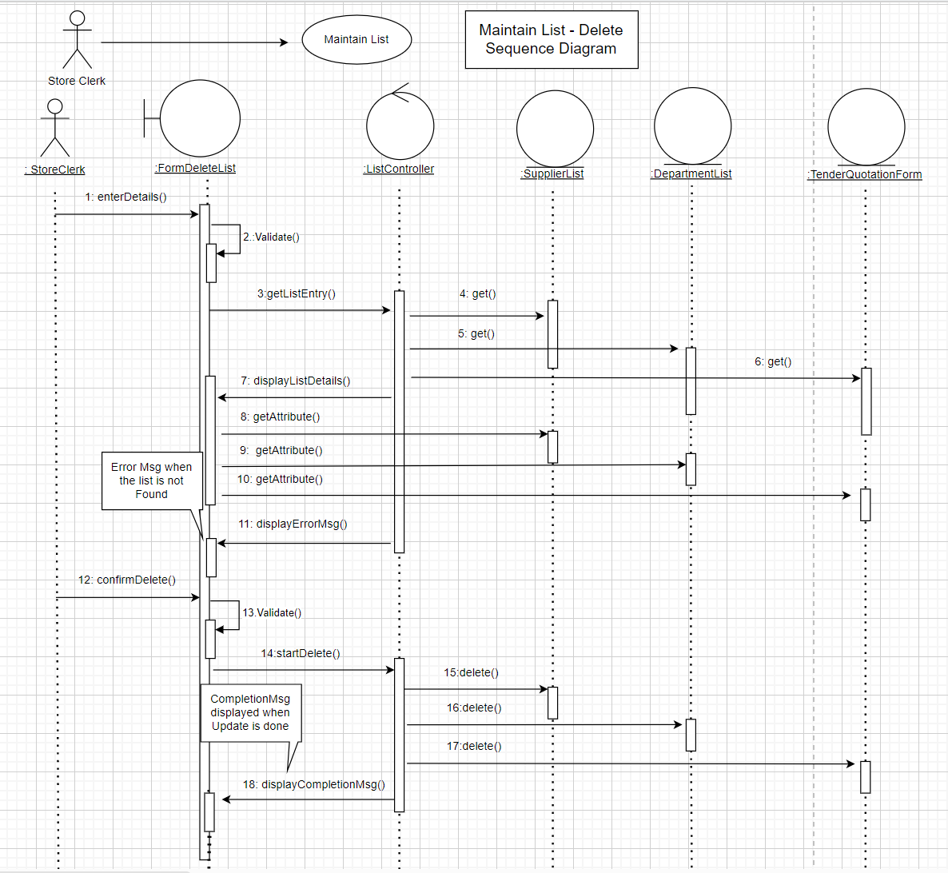

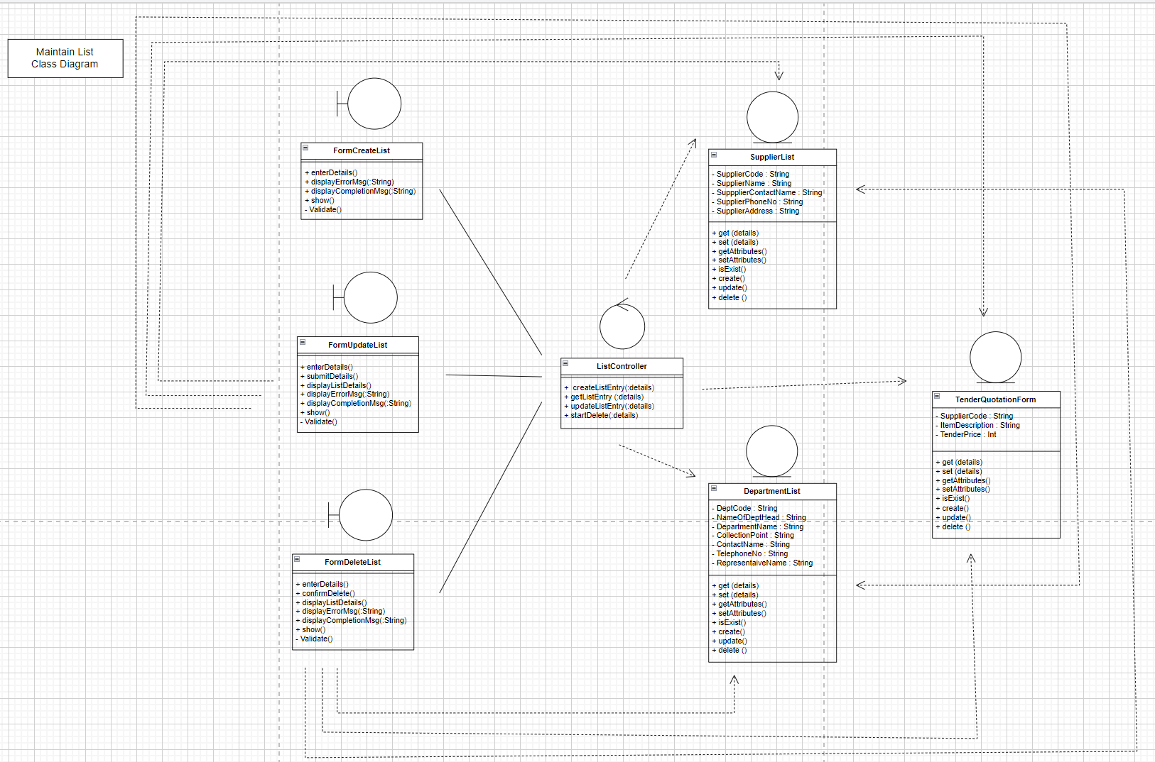

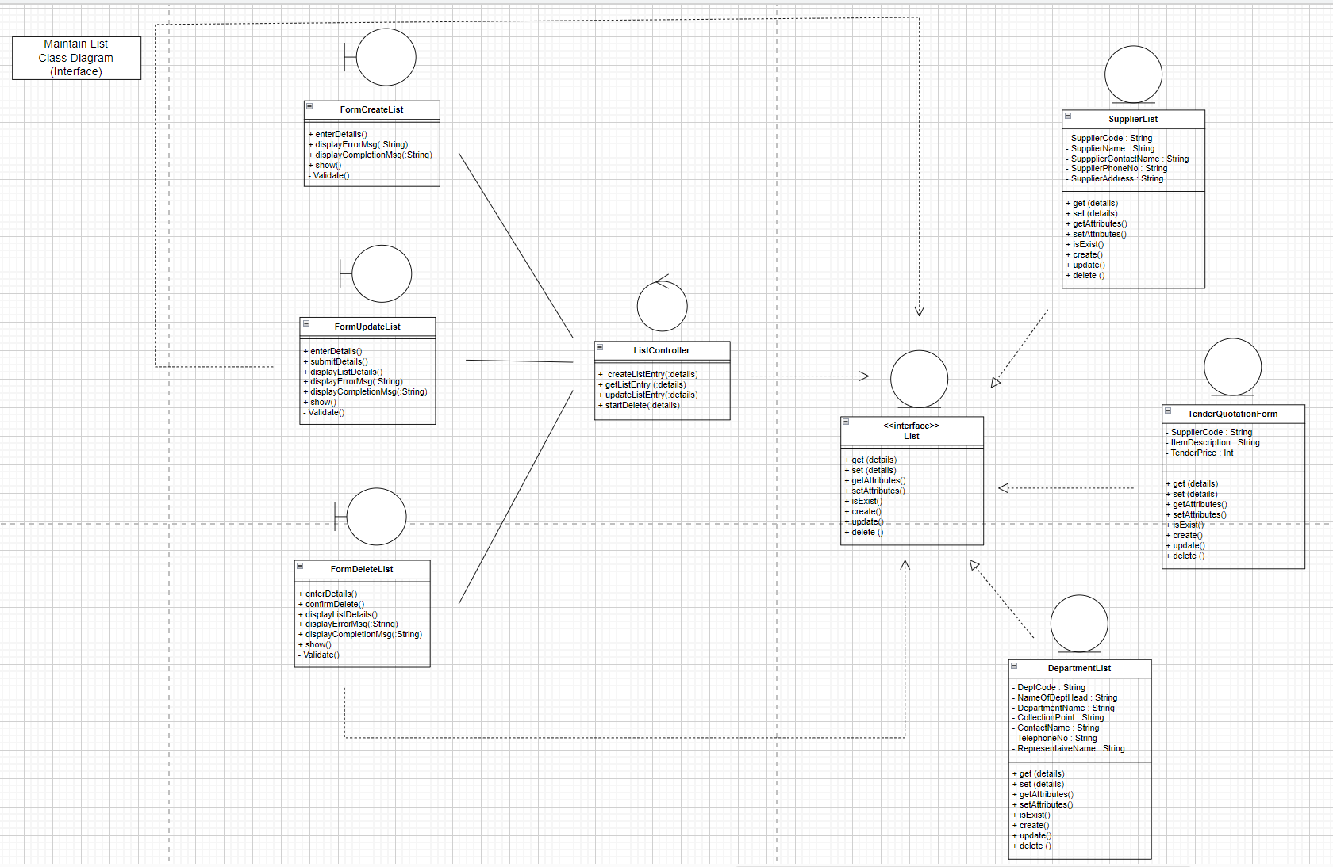

**Use Case: Alert to Restock**

Alert Store Clerk when stocks inventory is low and restocking is required.

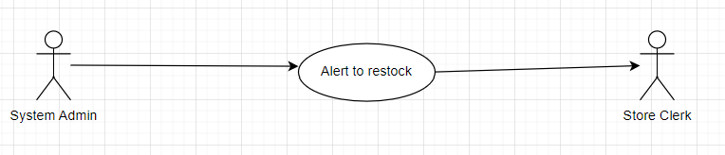

*Basic Flow:*

1. *SystemAdmin Enter each product ID*
2. *System retrieve product ID stocks status*
3. *SystemAdmin select and send notification of the product that require to reorder*
4. *System retrieves the List of items*
5. *System create a Reorder Record*
6. *System send data to “Notification”*
7. *“Notification” will be displayed on Store Clerk screen*

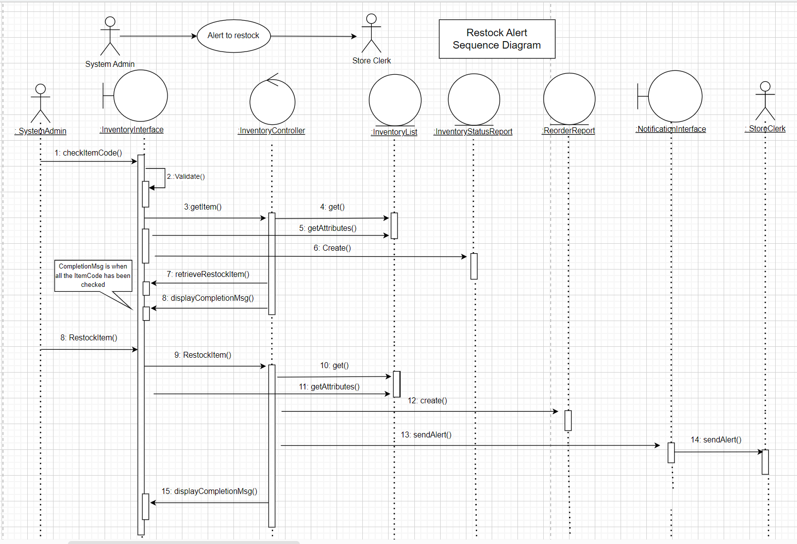

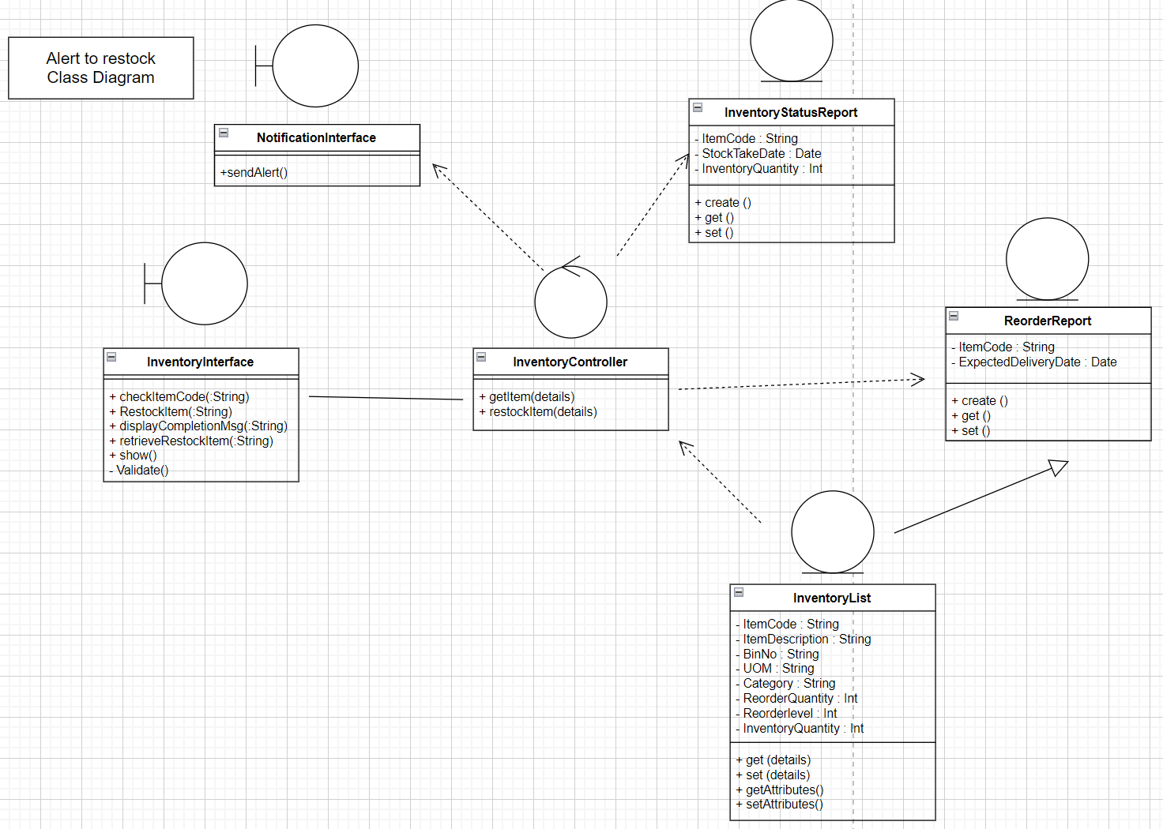

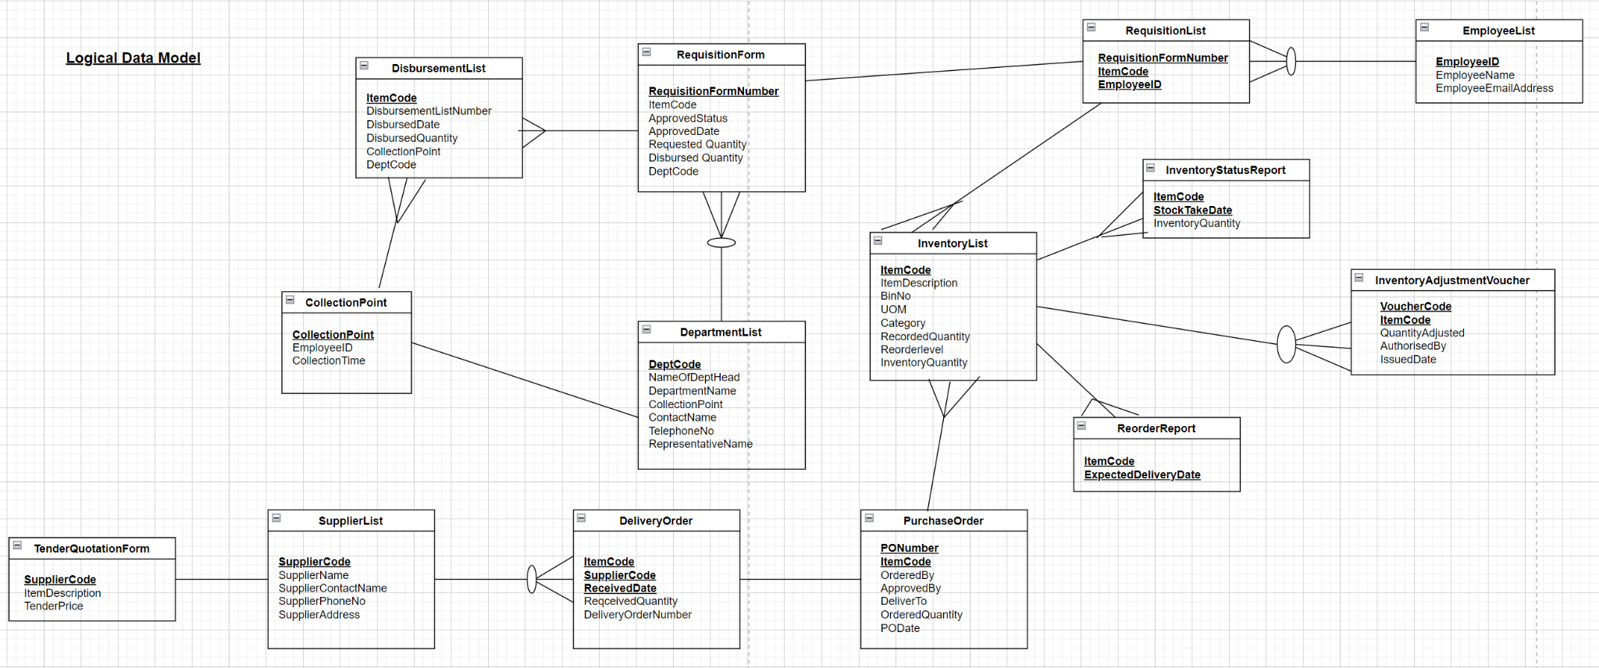

**Data Dictionary (Final Tables)**

|  |  |  |  |  |
| --- | --- | --- | --- | --- |
| **ENTITY** | **ATTRIBUTE NAME** | **Type** | **LEN** | **DEFINITION AND BUSINESS RULES** |
| **RequestionForm** | RequisitiionFormNumber | **string** | **15** | **Unique name for requisition form** |
|  | ItemCode | **string** | **10** | **Unique name for item. Start with one alphabet and follow by 3 numbers.** |
|  | ApprovedStatus | **string** | **50** | **Head Of Department to approved**  **(if head of department not around), the person who sign need to input his/her name** |
|  | ApporvedDate | **date** | **8** | **Format: DDMMYY**  **Date when the Head of Department Approved the form** |
|  | RequestQuantity | **int** | **5** | **Quantity needed** |
|  | DisbursedQuantity | **int** | **5** | **Quantity provided by Store** |
|  | DeptCode | **string** | **10** | **Department ID** |
|  |  |  |  |  |
| **ReorderReport** | ItemCode | **string** | **10** | **Unique name for item. Start with one alphabet and follow by 3 numbers.** |
|  | ExpectedDeliveryDate | **date** | **8** | **Format: DDMMYY**  **Estimated Time of Receipt of the Reorder Item** |
|  |  |  |  |  |
| **InventoryAdjusmentVoucher** | VoucherCode | **string** | **10** | **Unique code for the Adjustment Voucher** |
|  | ItemCode | **string** | **10** | **Unique name for item. Start with one alphabet and follow by 3 numbers.** |
|  | QuantityAdjusted | **int** | **5** | **Quantity Discrepancies (can be positive or negative value)** |
|  | AuthorisedBy | **string** | **50** | **Supervisor will sign off if the total discrepancies is less than or equal SGD 250.00**  **Manager will sign off if the total discrepancies is more than SGD 250.00** |
|  | IssuedDate | **date** | **8** | **Format DDMMYY**  **Date of issue of the Adjustment Voucher** |
|  |  |  |  |  |
| **DisbursementList** | ItemCode | **string** | **5** | **Unique name for item. Start with one alphabet and follow by 3 numbers.** |
|  | DisbursementListNumber | **string** | **10** | **Unique name for each Disbursement List** |
|  | DisbursedDate | **date** | **8** | **Format: DDMMYY**  **Date of creation of the Disbursement List** |
|  | DisbursedQuantity | **int** | **5** | **Quantity to be delivered the Collection Point** |
|  | CollectionPoint | **string** | **100** | **Name of Place where to collect item delivery** |
|  | DeptCode | **string** | **5** | **Department ID** |
|  |  |  |  |  |
| **InventoryStatusReport** | ItemCode | **string** | **5** | **Unique name for item. Start with one alphabet and follow by 3 numbers.** |
|  | StockTakeDate | **date** | **8** | **Format: DDMMYY**  **Date which physical stocktake was done** |
|  | InventoryQuantity | **int** | **5** | **Number of quantity in store** |
|  |  |  |  |  |
| **CollectionPoint(CS)** | CollectionPoint | **string** | **100** | **Name of Place where to collect item delivery** |
|  | EmployeeID | **string** | **10** | **Employee ID** |
|  | CollectionTime | **date** | **8** | **Collection time for store delivery** |
|  |  |  |  |  |
| **SupplierList** | SupplierCode | **string** | **15** | **Unique character for Supplier** |
|  | SupplierName | **string** | **15** | **Supplier Company Name** |
|  | SupplierContactName | **string** | **15** | **Supplier Contact Name** |
|  | SupplierPhoneNo | **int** | **10** | **Supplier Phone Number** |
|  | SupplierAddress | **string** | **100** | **Supplier Address** |
|  |  |  |  |  |
| **TenderQuotationForm** | SupplierCode | **string** | **5** | **Unique character for supplier** |
|  | ItemDescription | **string** | **250** | **Item description** |
|  | TenderPrice | **int** | **10** | **Price of tender price for each item** |
|  |  |  |  |  |
| **DeliveryOrder** | ItemCode | **string** | **5** | **Unique name for item. Start with one alphabet and follow by 3 numbers.** |
|  | SupplierCode | **string** | **5** | **Unique character for supplier** |
|  | ReceivedDate | **date** | **8** | **Format : DDMMYY**  **Date of Delivery** |
|  | ReceivedQuantity | **int** | **5** | **Quantity Received** |
|  | DeliveryOrderNumber | **string** | **50** | **Unique reference number from Supplier** |
|  |  |  |  |  |
| **RequisitionList** | RequisionFormNumber | **string** | **50** | **Unique name for requisition form** |
|  | ItemCode | **string** | **5** | **Unique name for item. Start with one alphabet and follow by 3 numbers.** |
|  | EmployeeID | **string** | **10** | **Employee ID** |
|  |  |  |  |  |
| **DepartmentList** | DeptCode | **string** | **10** | **Department ID** |
|  | NameOfDeptHead | **string** | **50** | **Name of department head** |
|  | DepartmentName | **string** | **50** | **Department Name** |
|  | CollectionPoint | **string** | **100** | **Name of Place where to collect item delivery** |
|  | ContactName | **string** | **50** | **The point of contact for the department** |
|  | TelephoneNo | **string** | **10** | **Department telephone no.** |
|  | ReprsentativeName | **string** | **50** | **The nominated person to collect the disbursed item at the Collection Point** |
|  |  |  |  |  |
| **PurchaseOrder** | PONumber | **string** | **10** | **Unique name for the PO (Format: ##-####/A)** |
|  | ItemCode | **string** | **5** | **Unique name for item. Start with one alphabet and follow by 3 numbers.** |
|  | Orderedby | **string** | **50** | **Name of person who raised the PO** |
|  | Approvedby | **string** | **50** | **Name of person who approved the PO**  **(Tentatively the Supervisor or above)** |
|  | DeliverTo(University) | **string** | **50** | **Address of University** |
|  | OrderedQuantity | **int** | **10** | **Quantity to purchase** |
|  | PODate | **date** | **8** | **Date Format (DDMMYY)** |
|  |  |  |  |  |
| **InventroryList** | ItemCode | **string** | **5** | **Unique name for item. Start with one alphabet and follow by 3 numbers.** |
|  | ItemDescription | **string** | **250** | **Item description** |
|  | BinNo | **string** | **5** | **Location of stock in store** |
|  | UOM | **string** | **10** | **Unit of measurement** |
|  | Category | **string** | **50** | **Category of item** |
|  | ReorderQuantity | **int** | **10** | **Number of reorder item** |
|  | Reorderlevel | **int** | **10** | **‘Healthy’ stock level of the inventory** |
|  | InventoryQuantity | **int** | **10** | **Total number of inventory** |
|  |  |  |  |  |
| **EmployeeList** | EmployeeName | **string** | **50** | **Name of Employee in department** |
|  | EmployeeID | **string** | **10** | **EmployeeID** |
|  | EmployeeEmailAddress | **string** | **100** | **Employee email** |